

HOUSING- PRICE PREDICTION

Submitted by:

ARGHA KUMAR MAITI

**ACKNOWLEDGMENT**

I would like to express my thanks of gratitude to mentors Swati Mahaseth as well as Flip Robo who gave me the golden opportunity to do this wonderful project on the topic Housing Price Prediction, which also helped me in doing a lot of research and I came to know about so many new things. I am really very thankful to them.

I am making this project to increase my knowledge and experience.

### INTRODUCTION

**Problem Statement:**

Houses are one of the necessary need of each and every person around the globe and therefore housing and real estate market is one of the markets which is one of the major contributors in the world’s economy. It is a very large market and there are various companies working in the domain. Data science comes as a very important tool to solve problems in the domain to help the companies increase their overall revenue, profits, improving their marketing strategies and focusing on changing trends in house sales and purchases. Predictive modelling, Market mix modelling, recommendation systems are some of the machine learning techniques used for achieving the business goals for housing companies. Our problem is related to one such housing company.

A US-based housing company named Surprise Housing has decided to enter the Australian market. The company uses data analytics to purchase houses at a price below their actual values and flip them at a higher price. For the same purpose, the company has collected a data set from the sale of houses in Australia. The data is provided in the CSV file below. The company is looking at prospective properties to buy houses to enter the market. You are required to build a model using Machine Learning in order to predict the actual value of the prospective properties and decide whether to invest in them or not. For this company wants to know:

* Which variables are important to predict the price of variable?
* How do these variables describe the price of the house? Technical Requirements:
* Data contains 1460 entries each having 81 variables. • Data contains Null values. You need to treat them using the domain knowledge and your own understanding. • Extensive EDA has to be performed to gain relationships of important variable and price. • Data contains numerical as well as categorical variable. You need to handle them accordingly. • You have to build Machine Learning models, apply regularization and determine the optimal values of Hyper Parameters. • You need to find important features which affect the price positively or negatively. • Two datasets are being provided to you (test.csv, train.csv). You will train on train.csv dataset and predict on test.csv file. The “Data file.csv” and “Data description.txt” are enclosed with this file.

Business Goal:

You are required to model the price of houses with the available independent variables. This model will then be used by the management to understand how exactly the prices vary with the variables. They can accordingly manipulate the strategy of the firm and concentrate on areas that will yield high returns. Further, the model will be a good way for the management to understand the pricing dynamics of a new market.

## Analytical Problem Framing

### Let's import required libraries:

**We will import the train file for analysis now:**

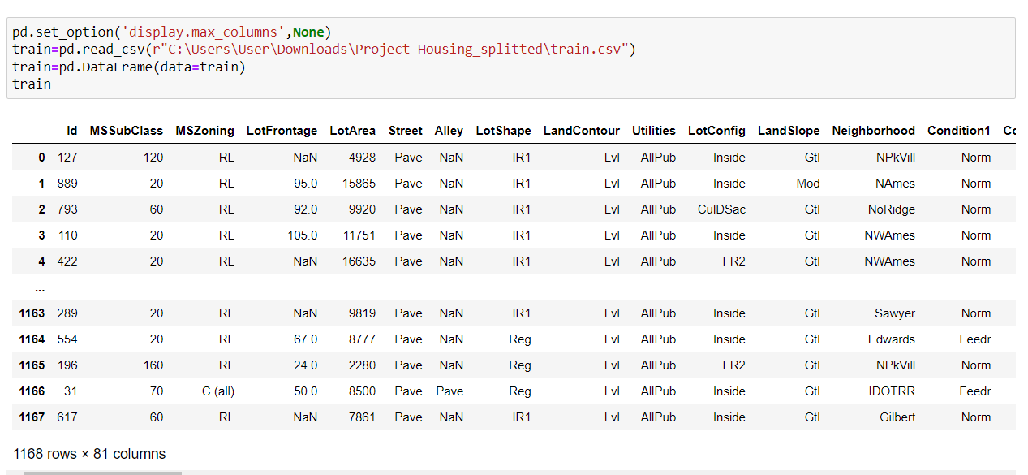

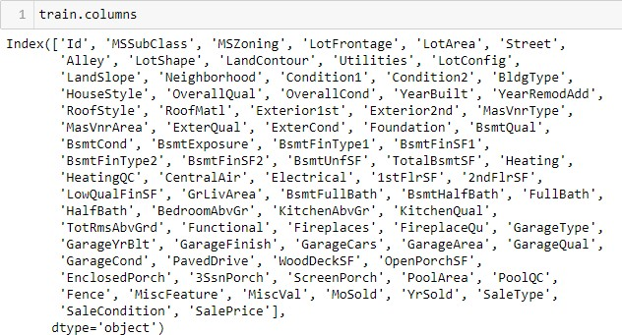

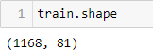Above is the list of all columns.

Dataset has 10683 rows and 11 columns.

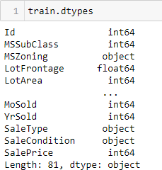

We can see both type of columns numerical and object type.

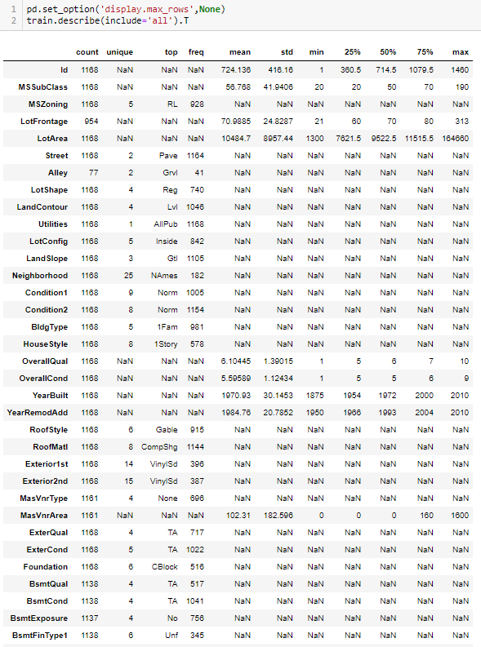

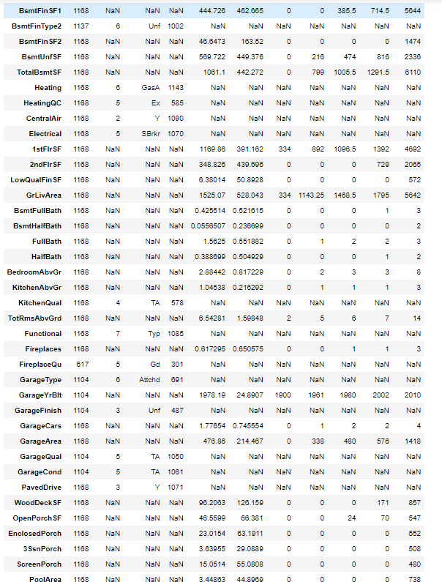

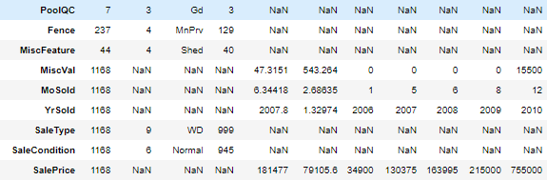

We can see count is all same for all variable, let's check for null values now:

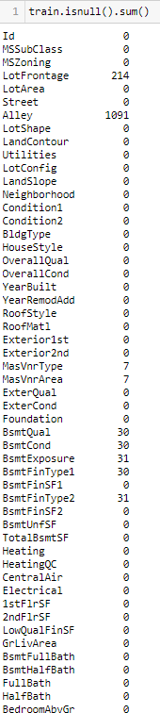 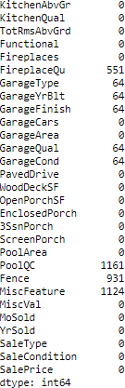

We can see null values in LotFrontage, Alley, MasVnrType, MasVnrArea, BsmtQual, BsmtCond, BsmtExposure, BsmtFinType1, BsmtFinType2, FireplaceQu, GarageType, GarageYrBlt, GarageFinish, GarageQual, GarageCond, PoolQC, Fence and MiscFeature.

Dropping columns which has too many null values i.e. Alley, FireplaceQu, PoolQC, Fence, MiscFeature. Also we will be working on null values according to datatype of the particular column.

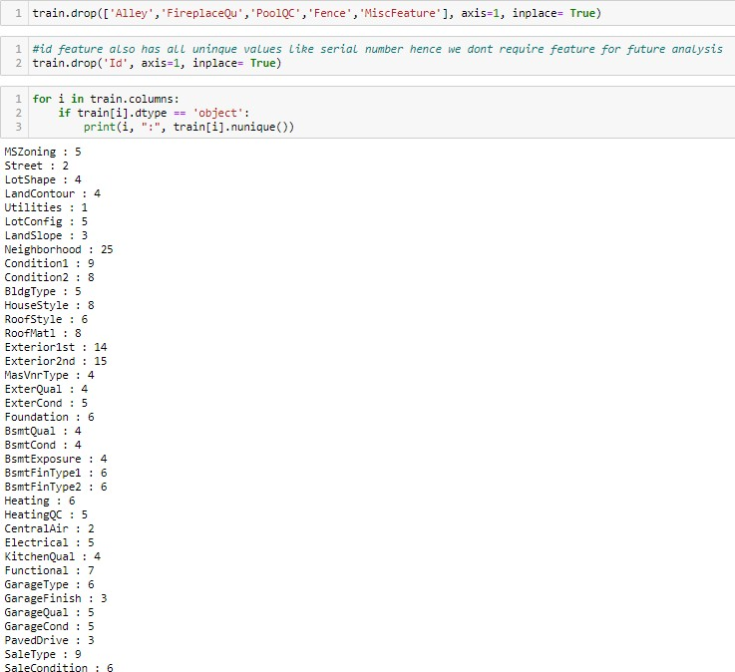



Utilities variable has only one unique data in it hence we dropped it lets make a list of categoical columns first

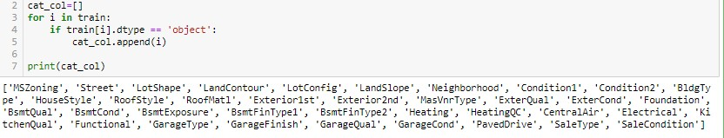

let check null values and value counts for all categorical variables

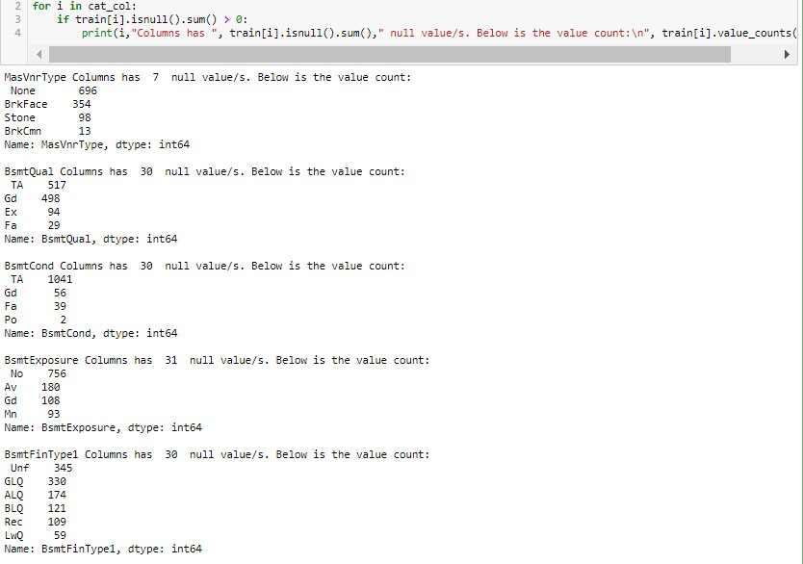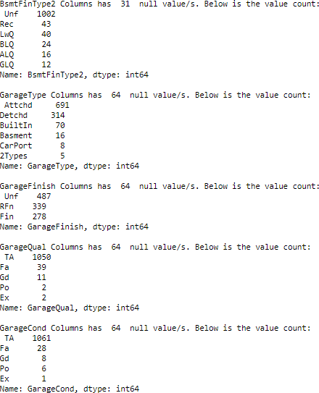

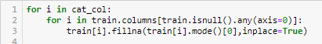Let’s replace null value of categorical column with mode.

Let’s make a list of numerical columns first

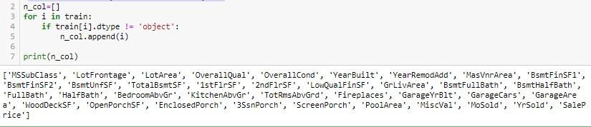

Let’s divide numerical columns list into discrete columns and continuous columns

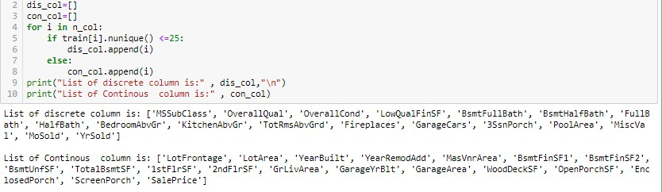

Let’s check for null values

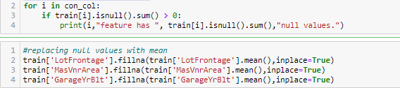

Let’s take a look at our train dataset now:

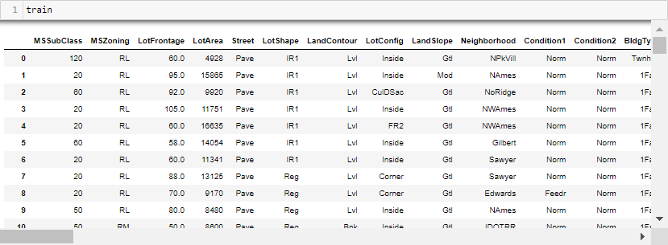

### Before proceeding ahead let’s do some data pre-processing:

let's create a new list after working on numerical variables

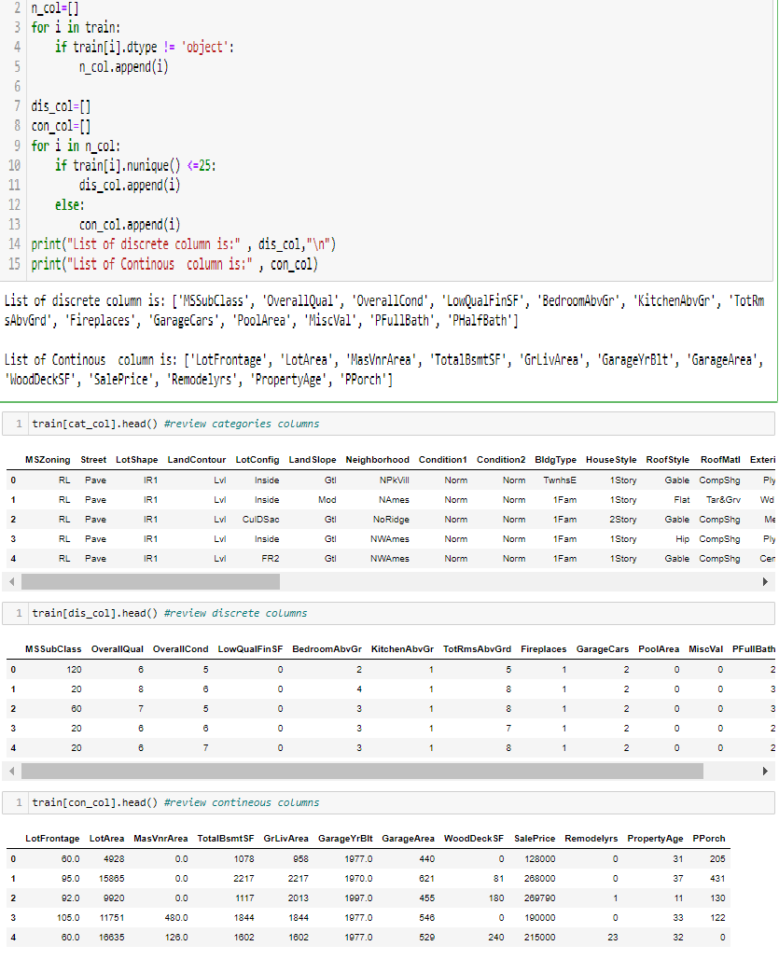

# Visualization:

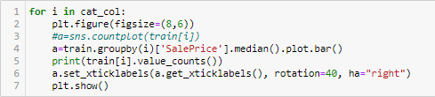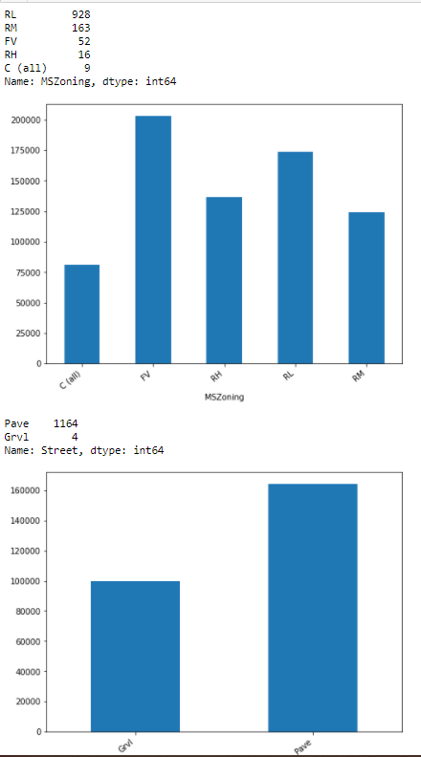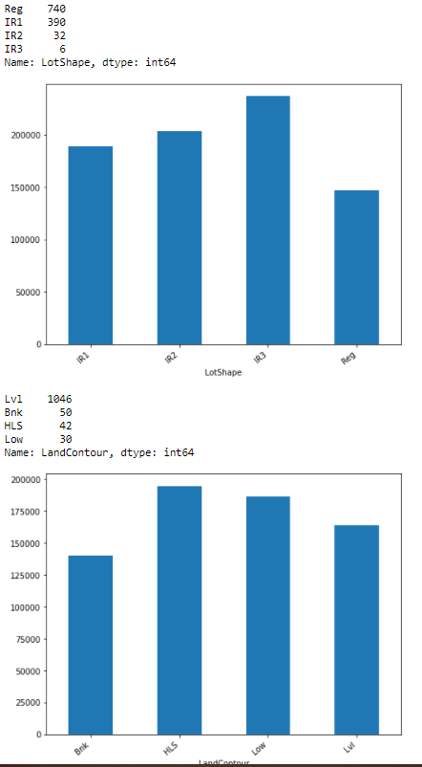

|  |  |
| --- | --- |
| Inside | 842 |
| Corner | 222 |
| CuJDSac | 69 |
| FR2 | 33 |
| FR3 | 2 |

Nane: LotCon-fiig, dtype: int64

NAmes 182

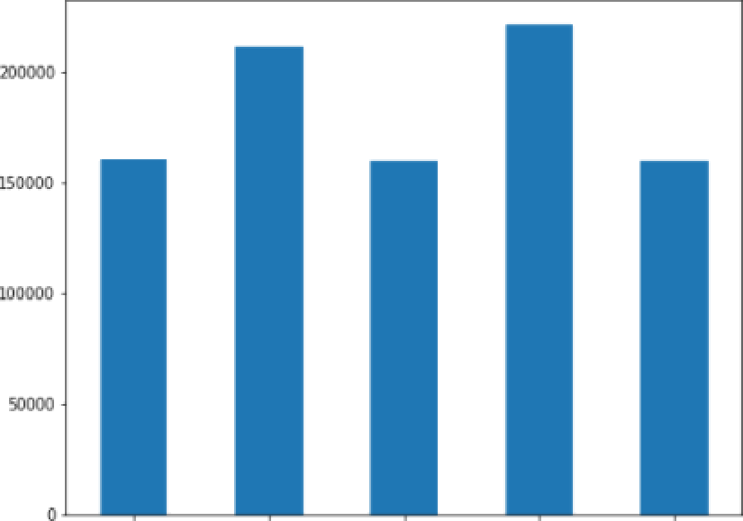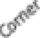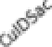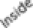

CollgCr 118

NridgHt 61

Sawyer 6B

M/lñzres 59

Sa\yerV 51

BrkSide SB



SU MBS

No*â* 51

Se'/ 12

Nane: LandSl ope, dtype: int64

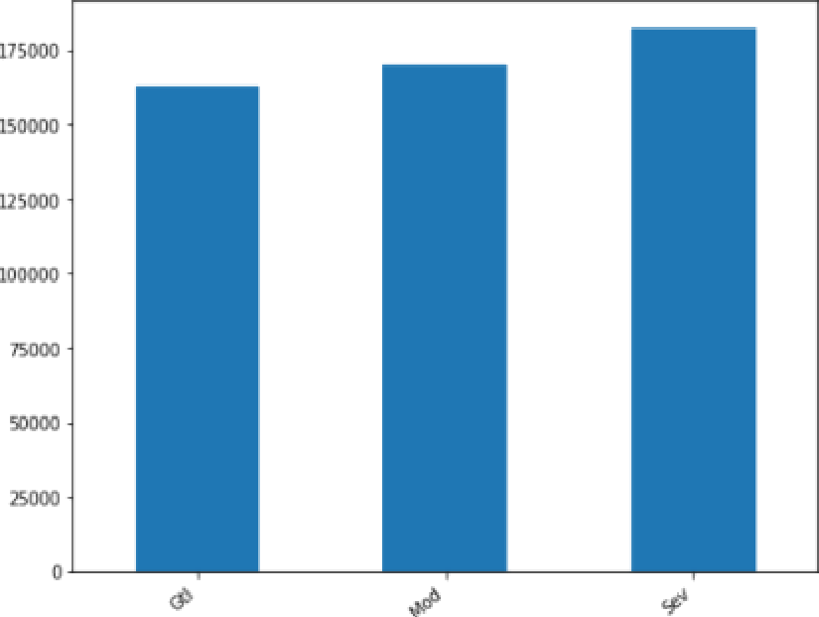

NoRidge 35

MitcEel 34

CLearCr 24

Tinber 24

SMSU 21

StDneBr 19

BLnngtn 15

BrDaJe 11

Veenker 9

NeadoaV 9

NPkVill 8

Blueste 2

Nane : ñezghborhoed, dtype: znt64



Nom 1005

Feedr 67

Artery 38

RRAn 28

No m

F ee dr Artery Pos M

1154

6

2

2

RRAe 9

PosA 6

RRNn 4

RRNe 2

Nane: Cond it ion 1, dtyge! int64

RRNn l

RRAn l

RRAe l

Name: Condition2, dtype: int64

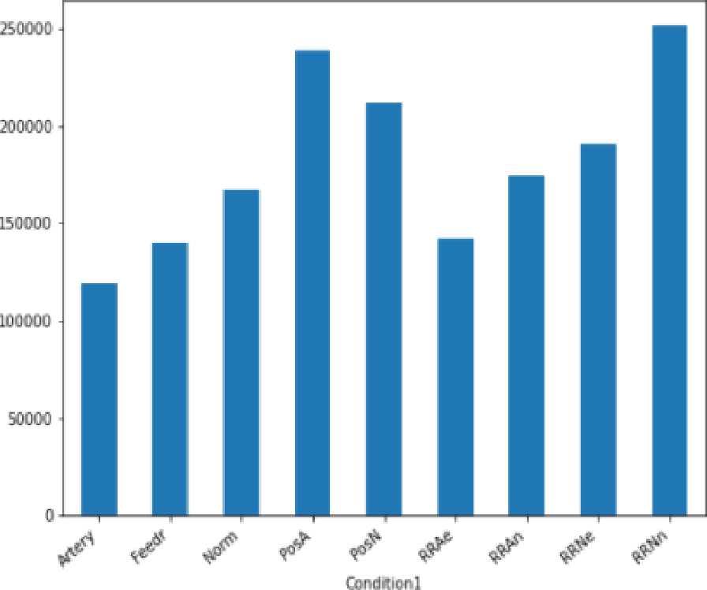 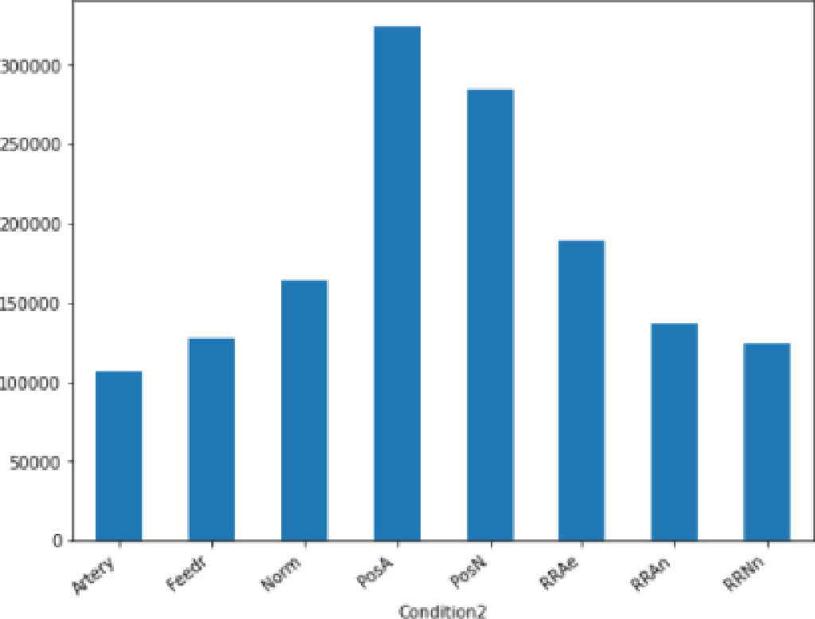

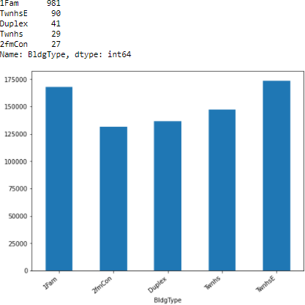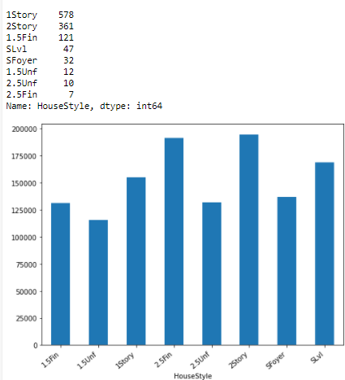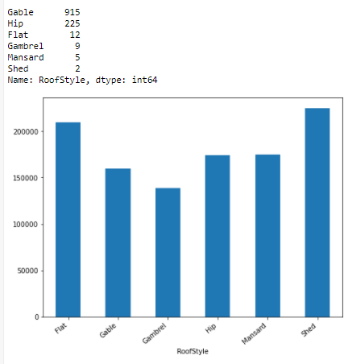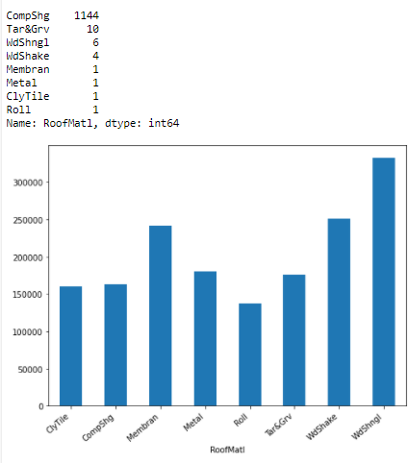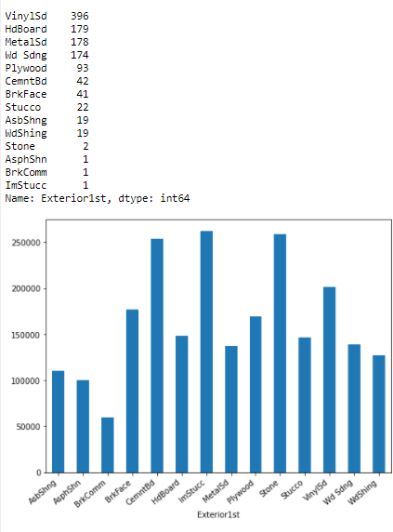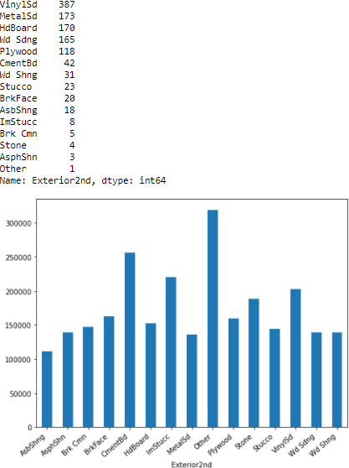

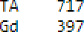.one 7é3

3rkFace 354

Stare 98

Nare: .'asVrrType, dtype: int6^ Fa ]1

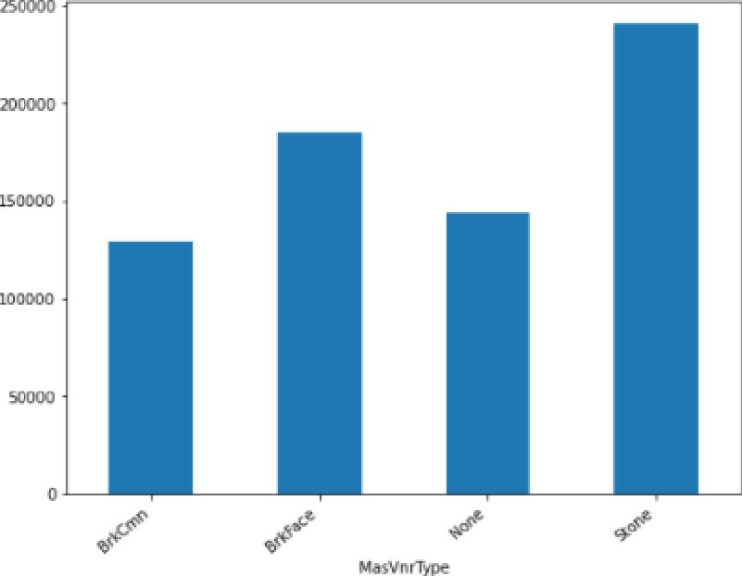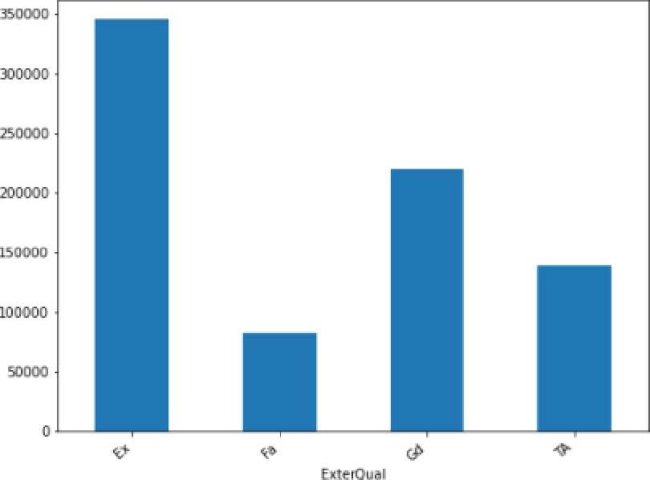

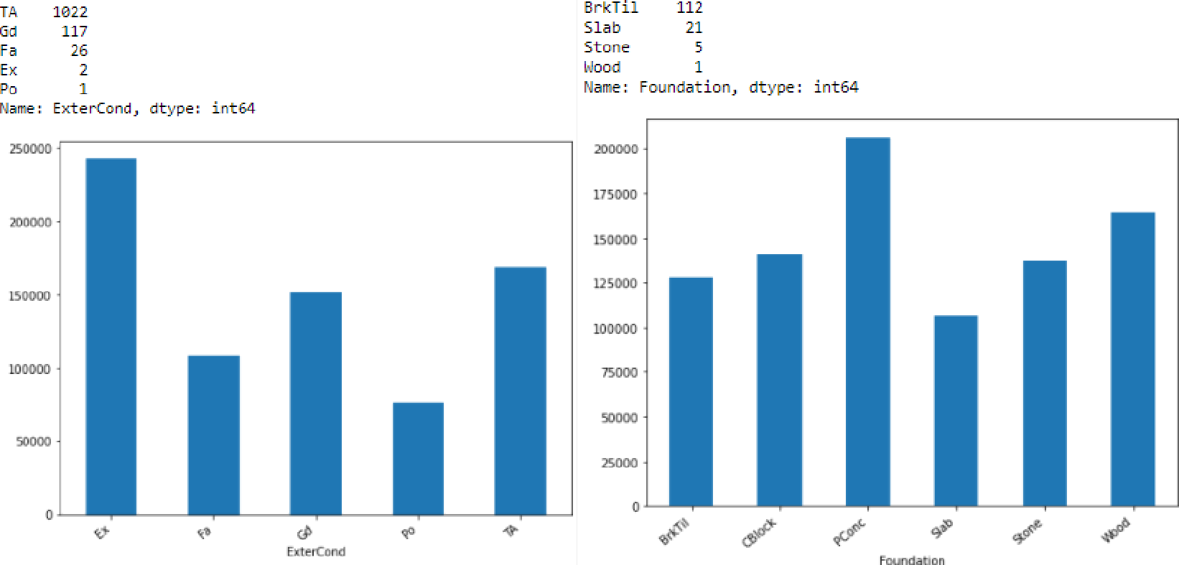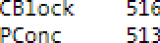

TA 1871

Gd 56

Fa D9

Nane: BsutCond, dtype: lnt64

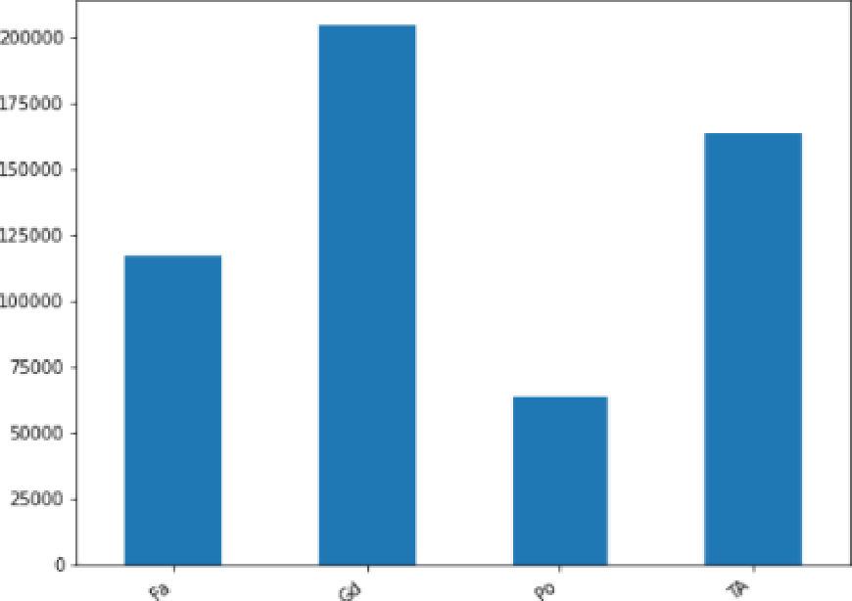

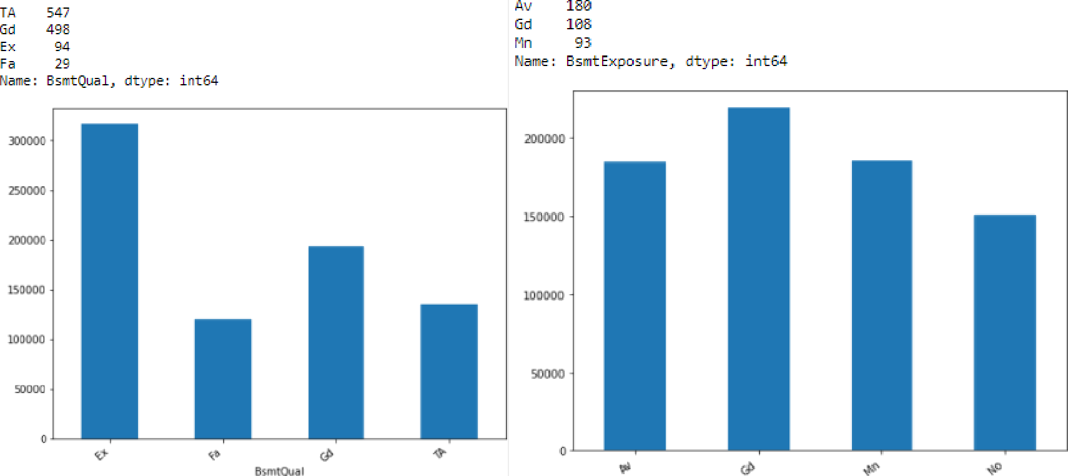ND 787

Uni- 1B33

Rec 43

LQ 40

BLq z‹

ALq 1s

sLq 12

Nane : Bscit FinType2, dtype: lnt64

GasW 14

Grav 5

WaJl 4

OtflW

Floor

Nane: Heating, dtype: 1nt64

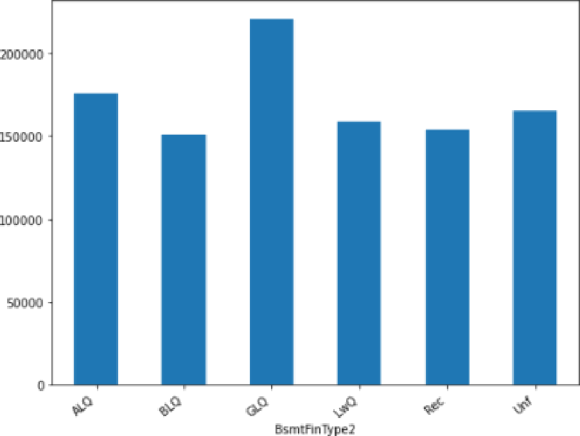 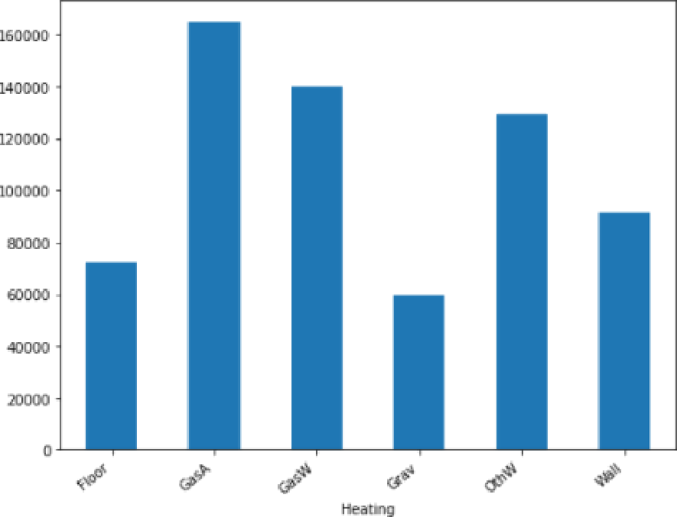

Ex 5B5

Gd 192

Fa 3B

Pa 1

Nane: Heat in ggC, dty'pe: Tnt64

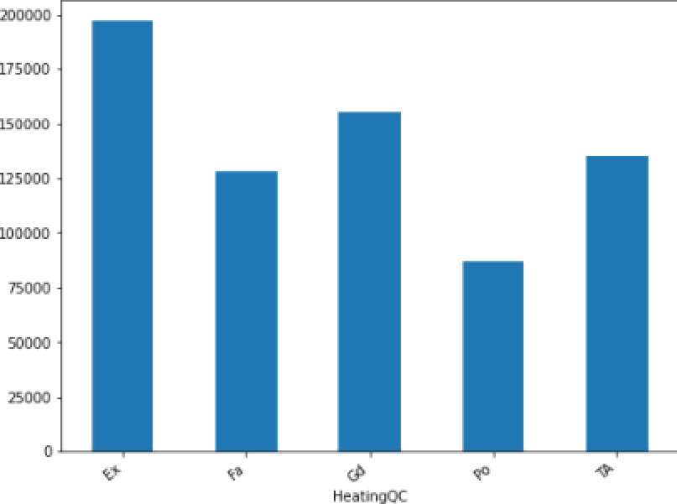

|  |  |
| --- | --- |
| SBrkr | 1076 |
| Fused | 74 |
| FuseF | 2J |
| FuseP | 2 |

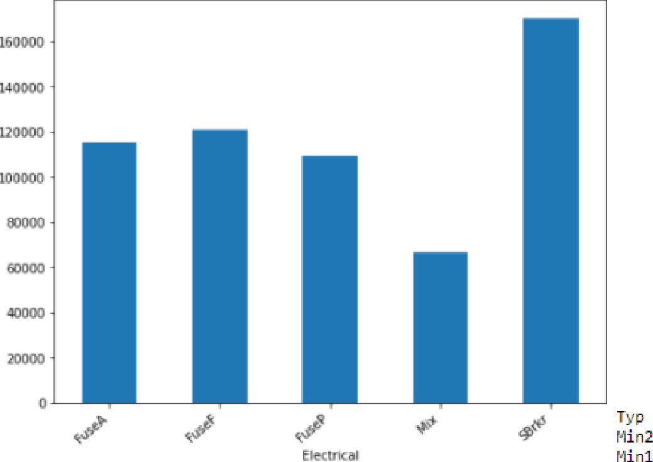Name: Electrical, dtype : int64

*TA* 57B

Gd 47B

Er 82



Nane : K itc he nQu al, dt \' pe: int64

y ggg

N 7B

Name: Centralâir, dtype: imt64

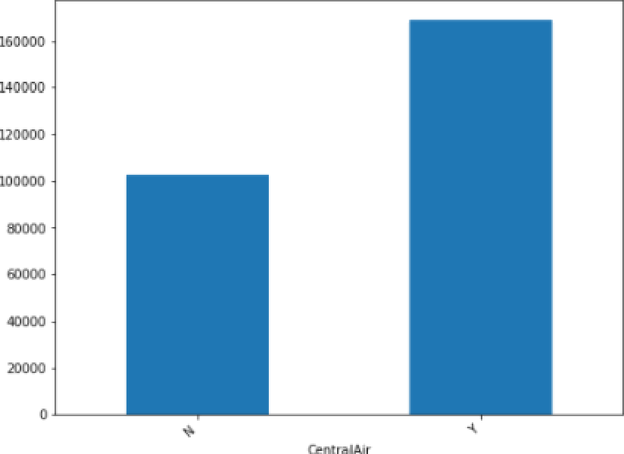

10B5

25

Mod 12

Maj1 11

Maj2 4

Se'7 l

Name: Functional, dtype: iut6Q

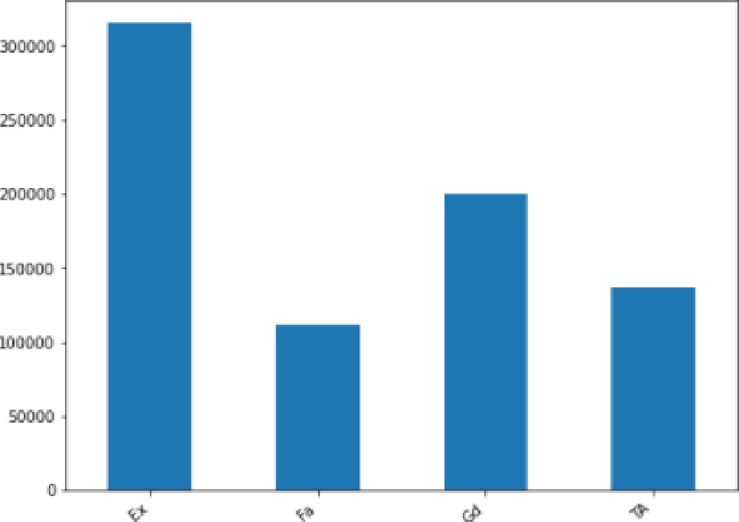 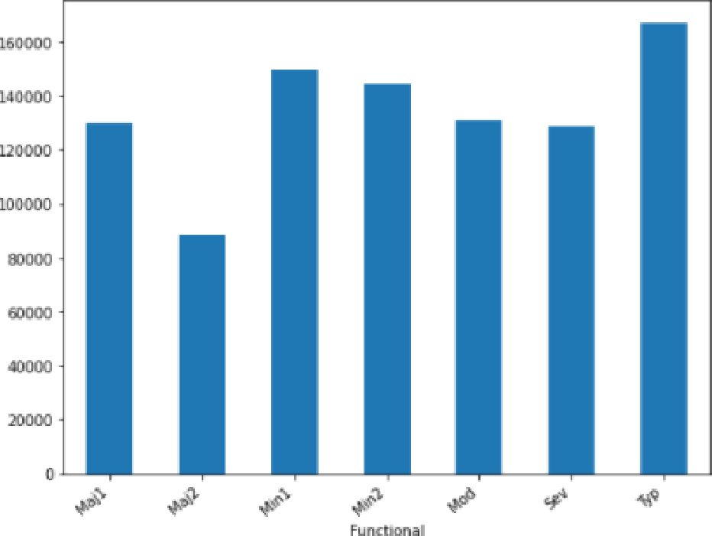



3ui1tIn 7d

Ln{ 551

9Fn 339

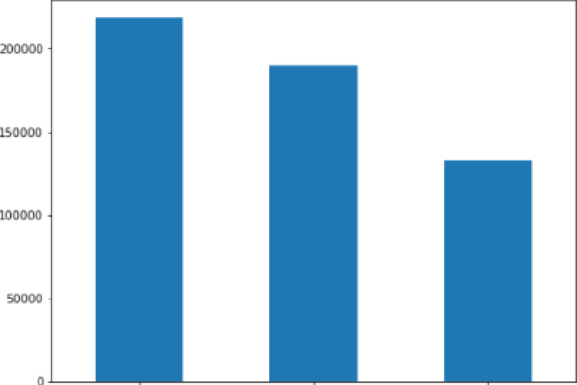

|  |  |
| --- | --- |
| TA | 1’114 |
| Fa | 39 |
| G d | 11 |
| a | 2 |
| E x | 2 |



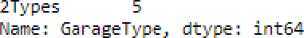

  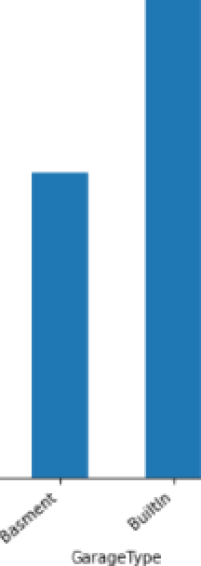   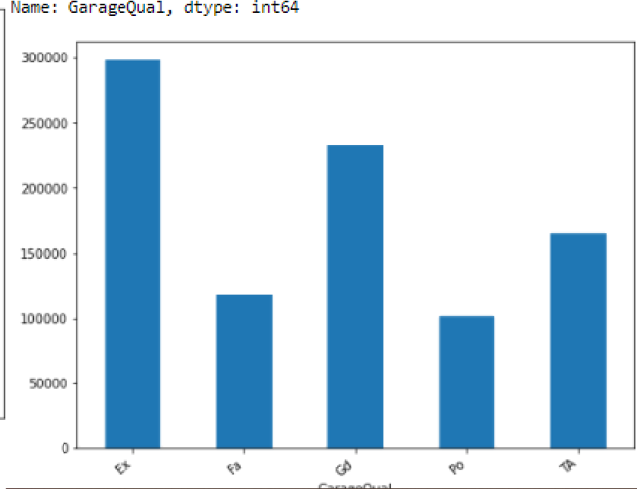

|  |  |
| --- | --- |
| TA | 1125 |
| Fa | 28 |
| Gd | 8 |
| Po | 6 |

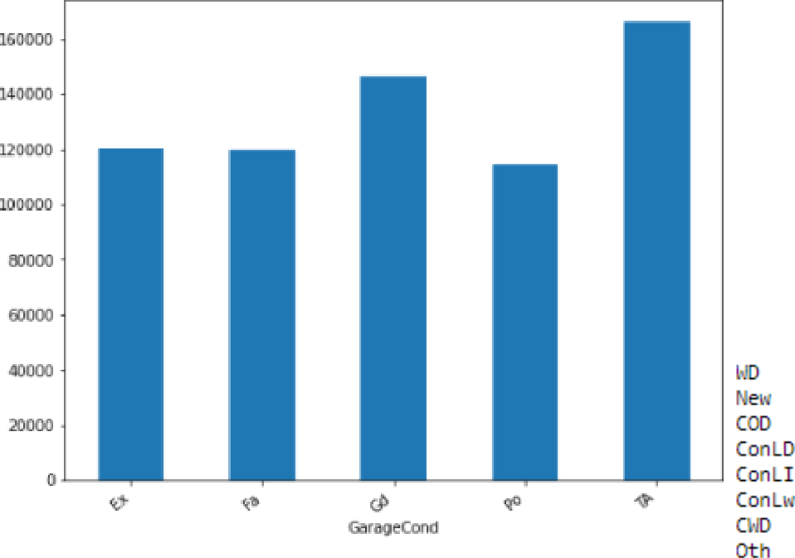Name: GarageC and, dtyge: int64

999

Y 1071

N 74

Name: PavedDr i^/e, dtyge: int64

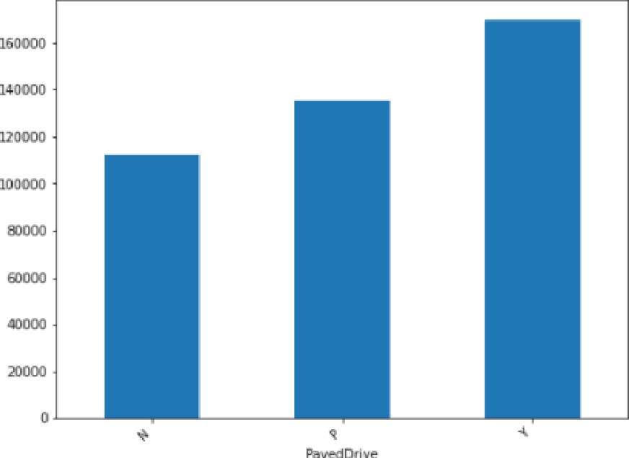

|  |  |
| --- | --- |
| Nomal  PaMial | 945  1B8 |
| Abn orml | 81 |
| Alloca | 12 |
| AdjLand | 4 |

Name: SaleCondition, dtype: int64

38

8

5

3

3

Con 2

Narr›e : Sale7ype, dtype : int64

I '0000

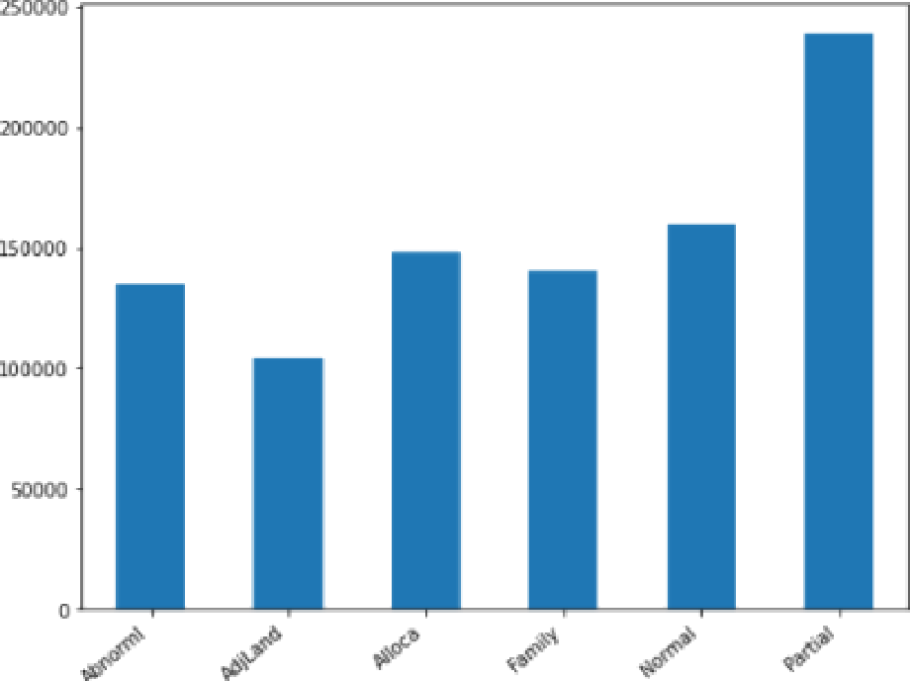

### Observations:

1. In MSZoning, highest sales price is of FV and lowest is of C(all).
2. For pave street sales price is higher than Grvl street.
3. For Lot shape, IR3 sales price is higher, then comes IR2, IR1 and Reg.
4. For LandContour, highest sales price is for HLS then Low,Lvl and lowest is Bnk.
5. With respect to LotConfig, sales price is, highest for FR3 and CulDSac, and for corner, FR2 and inside sales price is almost same.
6. For LandSlope, higest sales price is for Sev, then comes Mod and then Gtl.
7. With respect to Neighborhood, highest sales price is for NoRidge and NWAmes and lowest is for MeadowV.
8. With respect to Condition1, highest sales price is for RRNe and lowest is for Artery.
9. With respect to Condition2, highest sales price is for PosA and lowest is for Artery.
10. With respect to BldgType, highest sales price is for TwnhsE and lowest is for 2fmCon.
11. With respect to HouseStyle, highest sales price is for 2Story and lowest is for 1.5Unf.
12. With respect to RoofStyle, highest sales price is for Shed and lowest is for Gambrel.
13. With respect to RoofMatl, highest sales price is for WdShngl and lowest is for Roll.
14. With respect to Exterior1st, highest sales price is for ImStucc and lowest is for BrkComm.
15. With respect to Exterior2nd, highest sales price is for Other and lowest is for AsbShng.
16. With respect to MasVnrType, highest sales price is for Stone and lowest is for BrkCmn.
17. With respect to ExterQual, highest sales price is for Ex and lowest is for Fa.
18. With respect to ExterCond, highest sales price is for Ex and lowest is for Po.
19. With respect to Foundation, highest sales price is for PConc and lowest is for Slab.
20. With respect to BsmtQual, highest sales price is for Ex and lowest is for Fa.
21. With respect to BsmtCond, highest sales price is for Gd and lowest is for Po.
22. With respect to BsmtExposure, highest sales price is for Gd and lowest is for No.
23. With respect to BsmtFinType1, highest sales price is for GLQ and lowest is for LWQ.
24. With respect to BsmtFinType2, highest sales price is for GLQ and lowest is for BLQ.
25. With respect to Heating, highest sales price is for GasA and lowest is for Grav.
26. With respect to HeatingQC, highest sales price is for Ex and lowest is for Po.
27. With respect to CentralAir, highest sales price is for Y and lowest is for N.
28. With respect to Electrical, highest sales price is for SBrkr and lowest is for Mix.
29. With respect to KitchenQual, highest sales price is for Ex and lowest is for Fa.
30. With respect to Functional, highest sales price is for Typ and lowest is for Maj2.
31. With respect to GarageType, highest sales price is for BuiltIn and lowest is for CarPort.
32. With respect to GarageFinish, highest sales price is for Fin and lowest is for Unf.
33. With respect to GarageQual, highest sales price is for Ex and lowest is for Po.
34. With respect to GarageCond, highest sales price is for TA and lowest is for Po.
35. With respect to PavedDrive, highest sales price is for Y and lowest is for N.
36. With respect to SaleType, highest sales price is for Con and lowest is for Oth.
37. With respect to SaleCondition, highest sales price is for Partial and lowest is for AdjLand.

### Let’s have a look at discrete variable data:

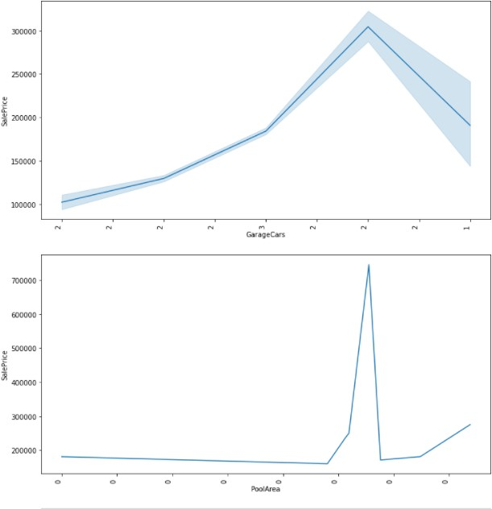

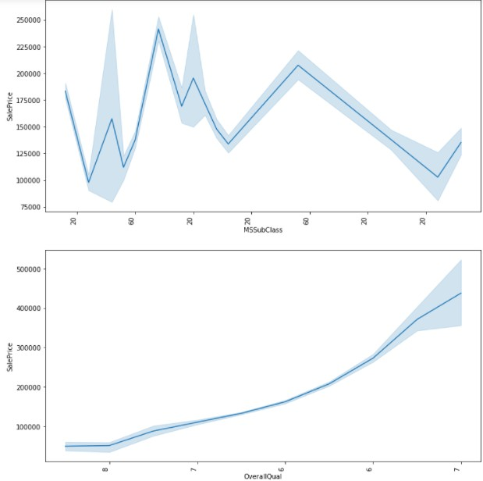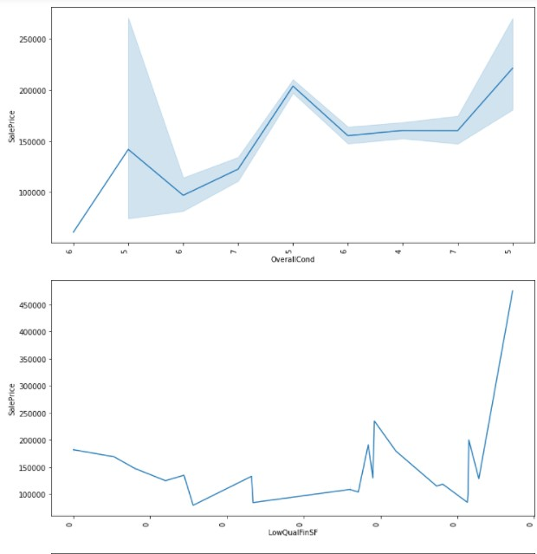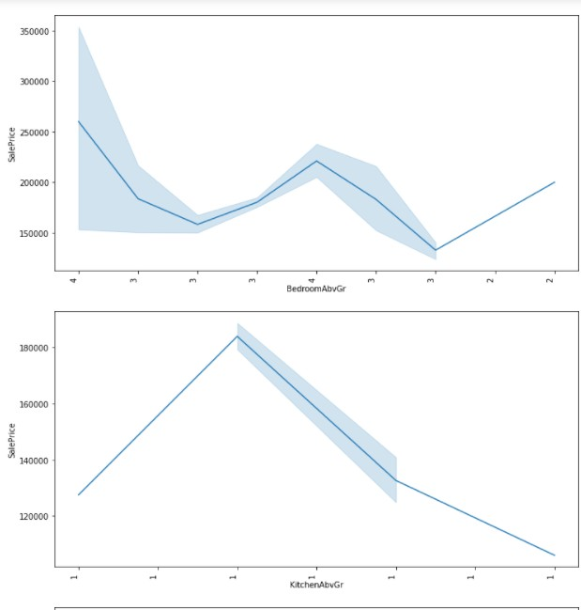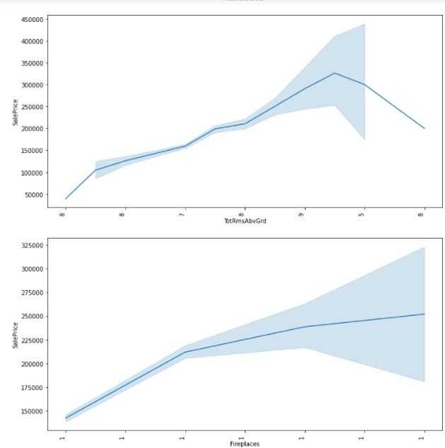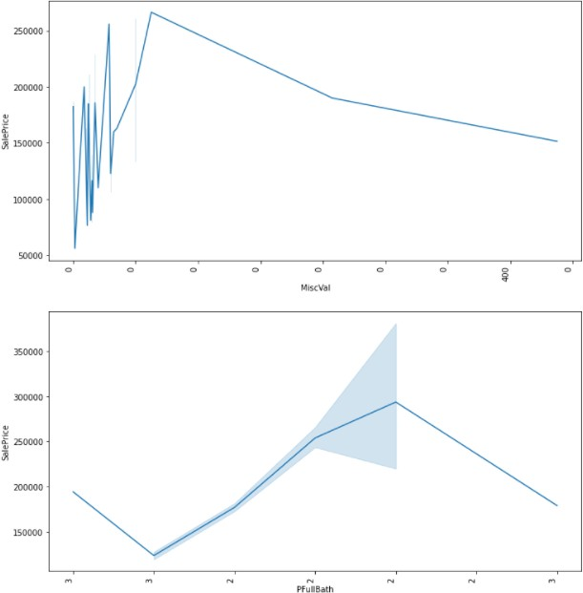

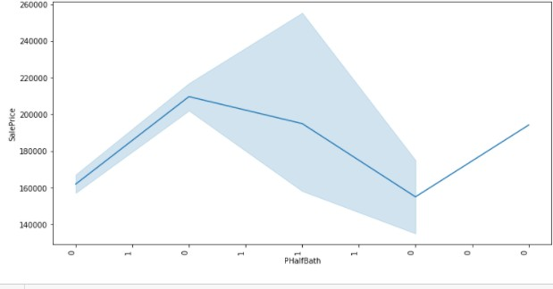

**Observation:**

1. With respect to MSSubClass variable, we can see sales price is differing for same values and different values as well.
2. With respect to OverallQual variable, was can see sales price is increasing.
3. With respect to OverallCond variable, sales price is fluctuating for all values.
4. With respect to LowQualFinSF variable, sales price is low for most of the variables and then increasing.
5. With respect to BedroomAbvGr variable, sales price is high at starting then its decreasing.
6. With respect to KitchenAbvGr variable, sales price is low at starting and again increasing at one point then again decreasing.
7. With respect to TotRmsAbvGrd variable, we can see sale price increasing and then decreasing after some point.
8. With respect to Fireplaces variable, we can see sales price is increasing.
9. With respect to GarageCars variable, sales price is low at starting and again increasing at one point then again decreasing.
10. With respect to PoolArea variable, sales price is low for most of the values increasing at some point and again decreasing.
11. With respect to MiscVal variable, sales price is fluctuating and then decreasing.
12. With respect to PFullBath, sales price is somewhat high in starting then decreasing again increasing and then again decreasing.
13. With respect to PHalfBath variable, sales price is low at start then increasing and then again decreasing then increasing.

### Let’s look at continuous variable data:

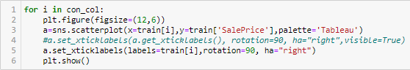

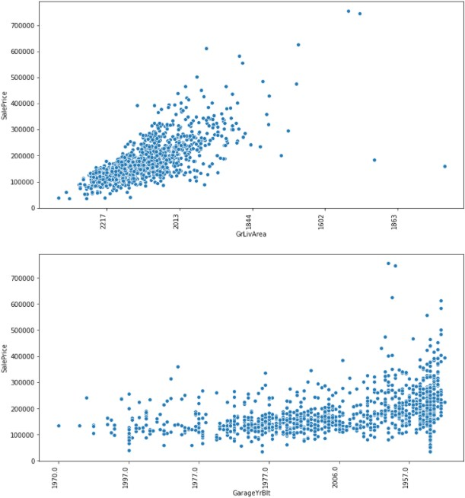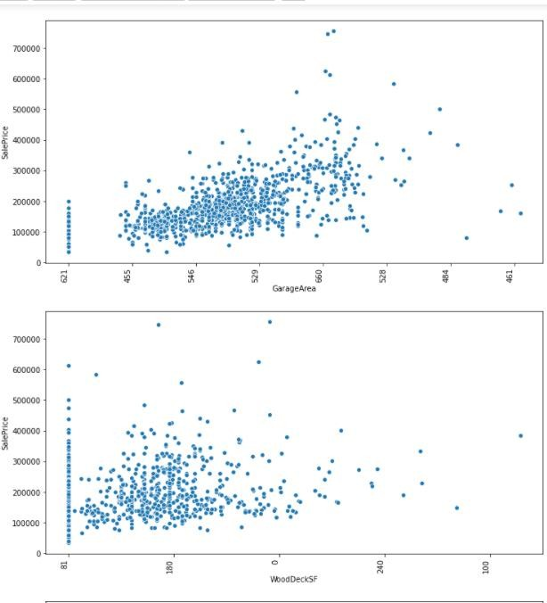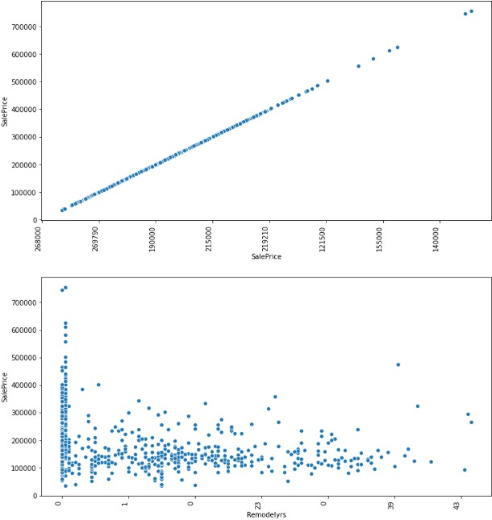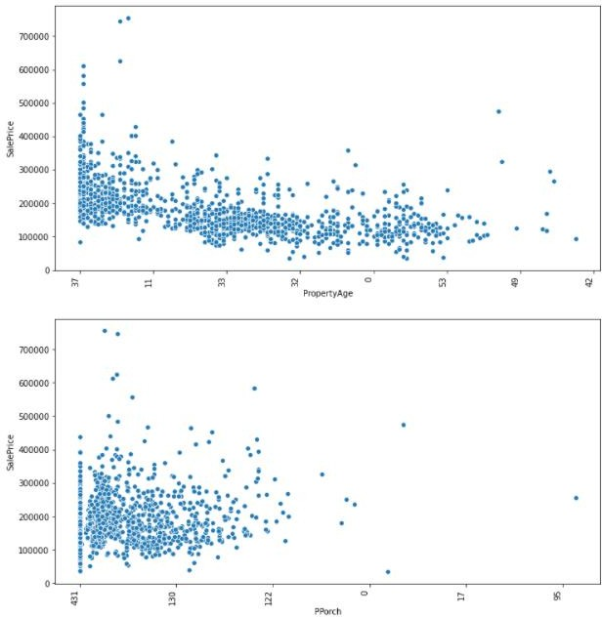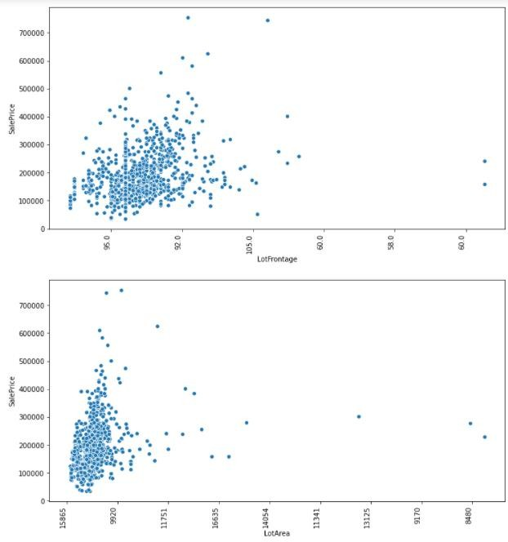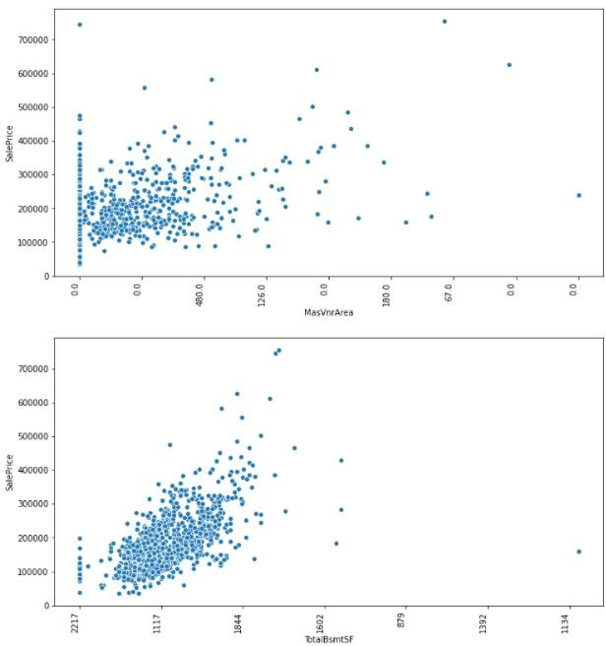

**Observation:**

1. With respect to LotFrontage, maximum values are ranging for 95.0 and 92.0.
2. With respect to LotArea, maximum values are ranging for 15865 and 9920.
3. With respect to MasVnrArea, maximum values are ranging for 0.0, 480.0 and 126.0.
4. With respect to TotalBsmtSF, maximum values are ranging for 2217, 1117 and 1844 and the trend is increasing.
5. With respect to GrLivArea, maximum values are ranging for 2217, 2013 and 1844 and the trend is increasing.
6. With respect to GarageYrBlt, maximum values are ranging for 1997.0, 1977.0, 2006.0 and 1957.0.
7. With respect to GarageArea, maximum values are ranging for 455, 546, 529, 660 and 528.
8. With respect to WoodDeckSF, maximum values are ranging for 81, 180 and 0.
9. With respect to Remodelyrs, maximum values are ranging for 0, 1, 23 and 39.
10. With respect to PropertyAge, maximum values are ranging for 37, 11, 33, 32, 0 and 53.
11. With respect to PPorch, maximum values are ranging for 431, 130 and 122.

### Let’s check the distribution of data now:

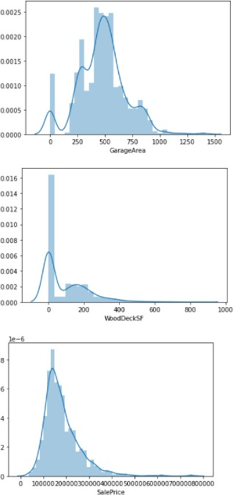

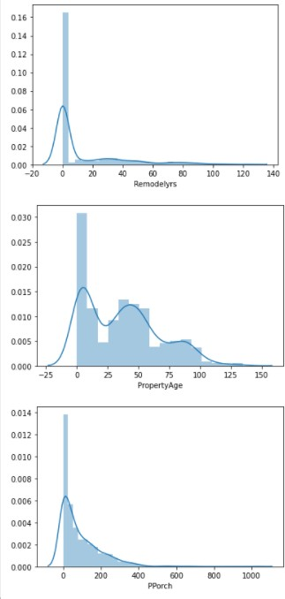

We can see for numerical columns data is not evenly distributed.

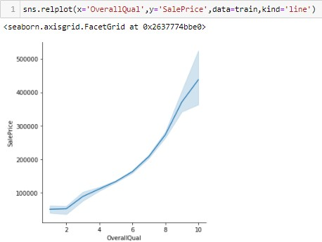

We can see positive relation between overallQual and SalePrice.

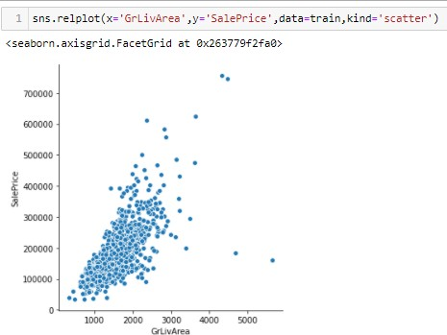

We can see positive relation between GrLivArea and SalePrice.

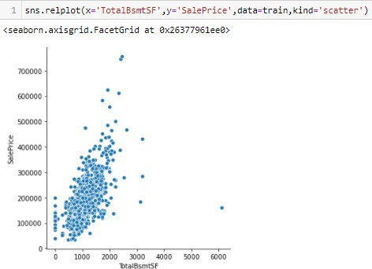

We can see positive relation between TotalBsmtSF and SalePrice.

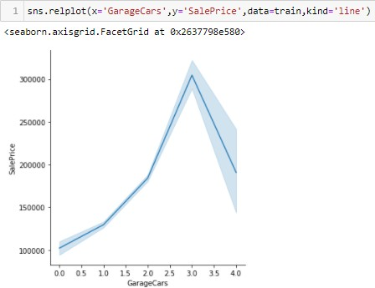

We can see positive relation between GarageCars and SalePrice.

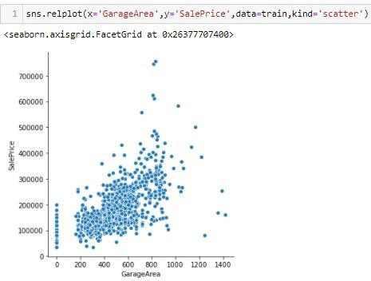

We can see positive relation between GarageArea and SalePrice.

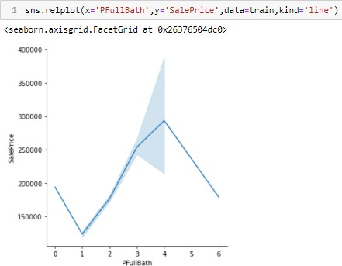

We can see positive relation between PFullBath and SalePrice.

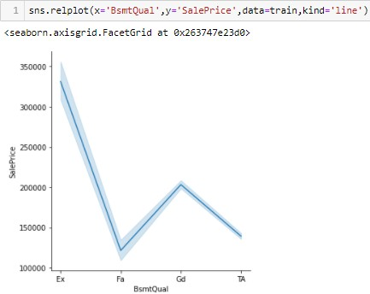

We can see negative relation between BsmtQual and SalePrice.

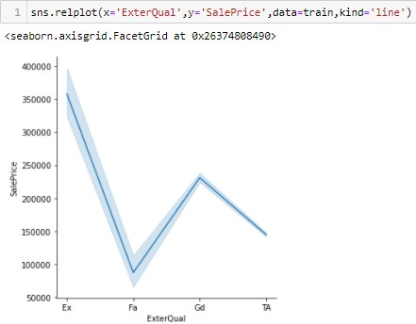

We can see negative relation between ExterQual and SalePrice.

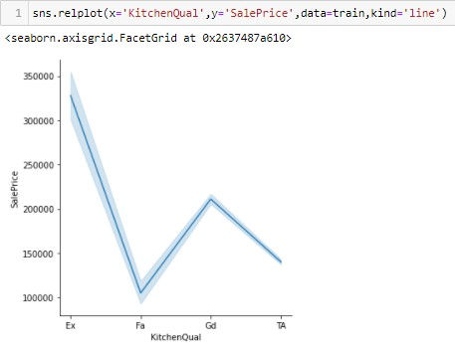

We can see negative relation between KitchenQual and SalePrice.

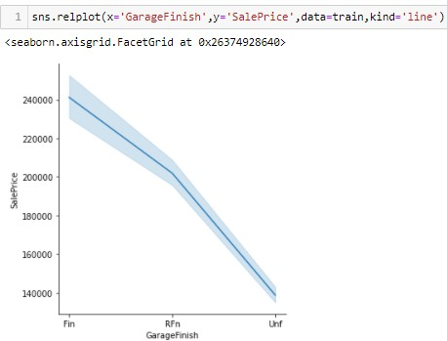

We can see negative relation between GarageFinish and SalePrice.

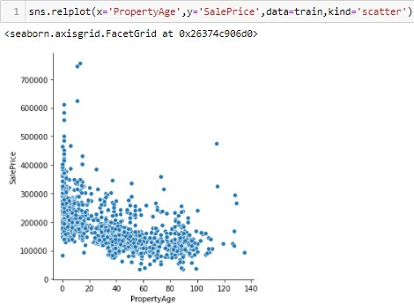

We can see negative relation between PropertyAge and SalePrice.

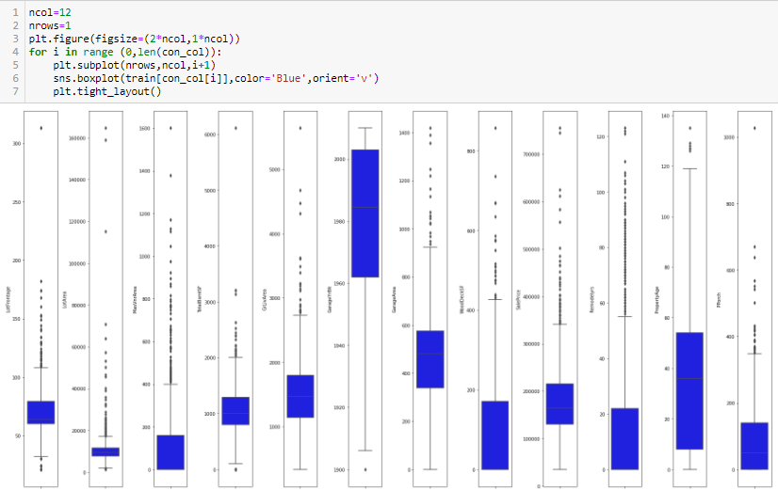Let’s check for outliers with the help of boxplot:

We can see outliers in all numerical variables.

### Some functions for further analysis:

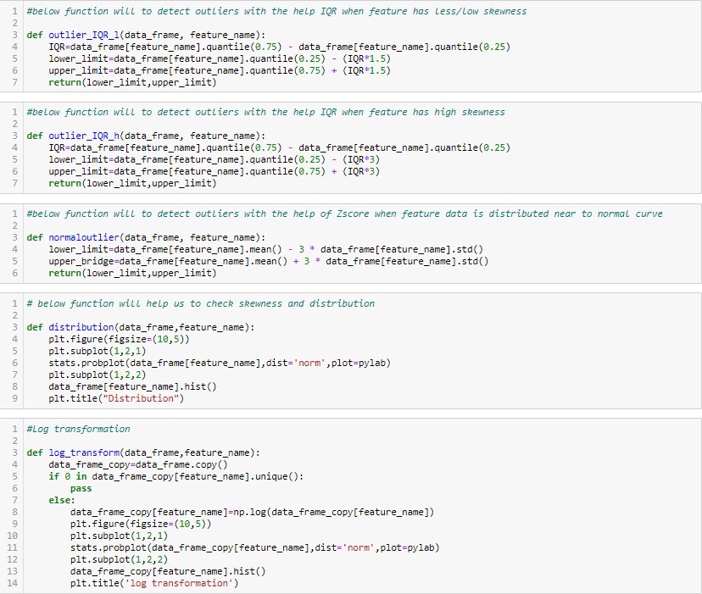

*4Re c iprocaL transfar.eat son*

def reczprocal_transform(data frame,feature_name): data_frame_copy=data frame.cOpy()

i-F B i n dat a_frane_cnpy [-Feat ure_nane j . un ique ( ) :

data £rarne_copy[featune_name]=I/data_Frane_cop\’[-Feature name] p1t . figure (figsi z e= (IO, 5 } )

p1t . subplot (1, 2,I)

stats .probp1ot (data_£nane_cop\’[feature nane] , dist= ' norr' plot=p\’1ab) p1t . subplot (1, 2, 2)

data £rarne_copy[featune_name] . his I ( ) p1t , title( ' r.°ciproczI I znsrcrratzon ' )



def sqaureroot_transform(data frame,feature_name): data_frame_copy=data frame.cOpy()

i-F B i n dat a_frane_cnpy [-Feat ure_nane j . un ique ( ) :

data £ r arne_c opy [featu ne_name ] =d ata_frane_c o py [Ie at ure_name ]” (1 /2 }

plt , Figure (figs i ie= (IB, 5 ) ) plt , sub plot:(1, Z, l )

stats .probp1ot (data_£nane_cop\’[feature nane] , dist= ' norr' plot=p\’1ab) p1t . subplot (1, 2, 2)

data £ r arne_c opy [featu ne_name ] . h i st ( )

plt , I it le ( ' 5c u é we no at I - é ns éc brat: en ' )



deF exponent T a1_t rans form( data_frame , feat ure_name ) :

data_frane_c o py= dat a_f r ame . copy ( )

if B i n dat a_frane_copy [ fe at ure_nane j . un ique ( ) :

data_1° r arne_c opy [ featune_name] =d ata_frane_c opy [Ie at ure_na me ] ” ’ (1 /1.2) p1t. f1gure (figs1E e= (1B, 5 ) )

p1t . subp1ot(1, 2,1)

stats .probp1at (data_1°nane_cop\’[feature_nane] , dist= ' norr' , plot=p\’1ab) p1t . subp1ot(1, 2, 2)

data_1°rarne_copy[featune_name] . his I ( ) p1t . t1tle( ' e ‹p oner t 1a. tra as fo-na.1or ' )

*Ill* lsysI transf:rn(data frane,featire lane)'

if I ii fata frane (‹pj|featJre lane].‹nI;ie()'

ilse!

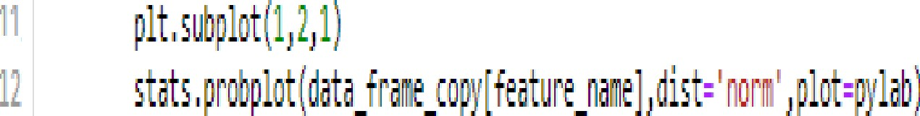Jata frax ‹:p¿feat‹re fane]•‹tats.Bzt/(fata fraie ‹:p)[feat\re lane]) 1! p1t fg\re(fIjsi:e•(tt,l))

li ;lt sil;lot(1,1,1)

* 1. lets ftse ti;y|feitri nsni|,1lst()

li ;lt tltli('li›(o› trsl!li•ni:lolJ

### Let's Work on features individually:

* 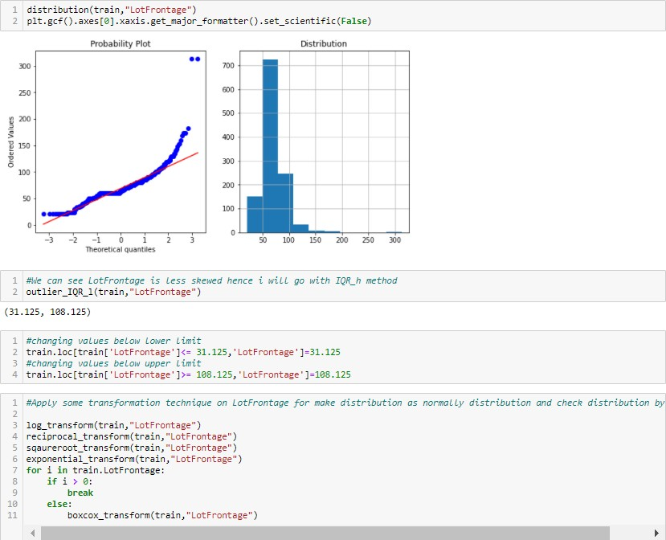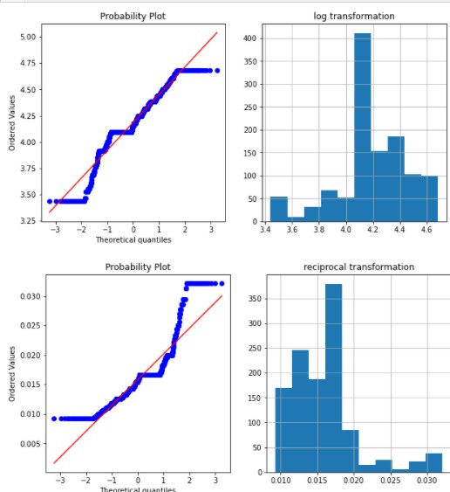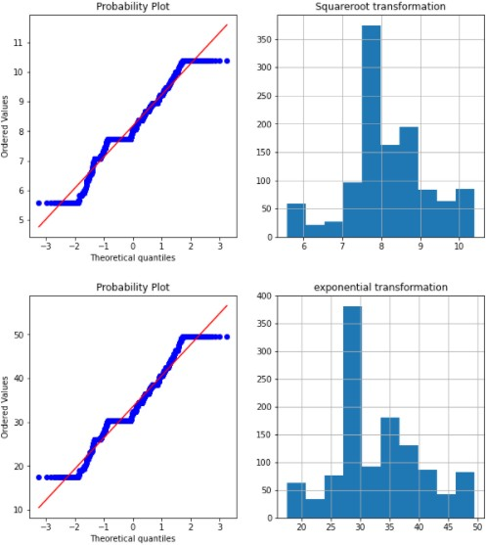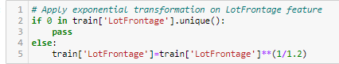**LotFrontage**
* LotArea

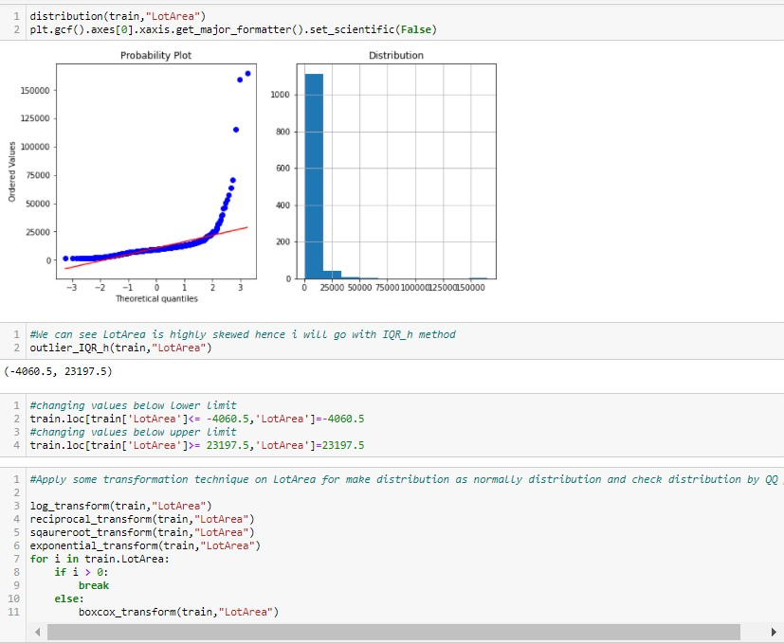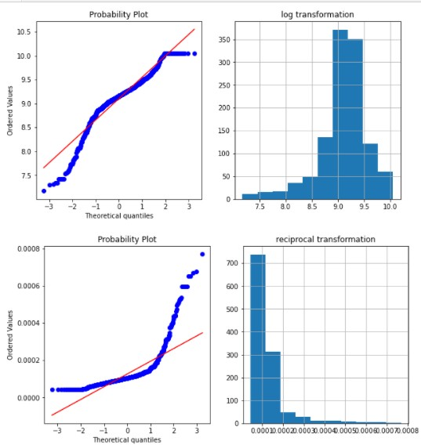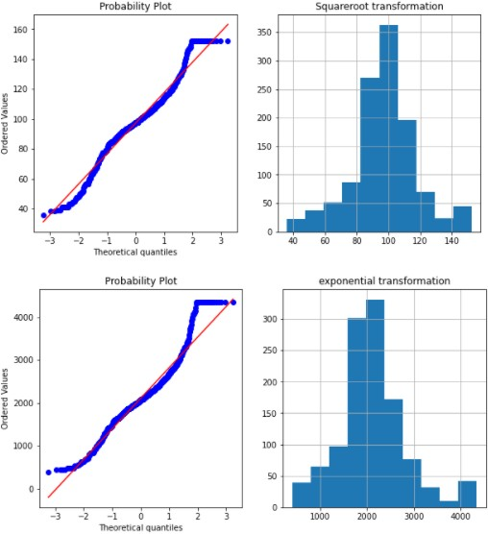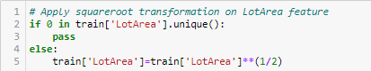

* MasVnrArea

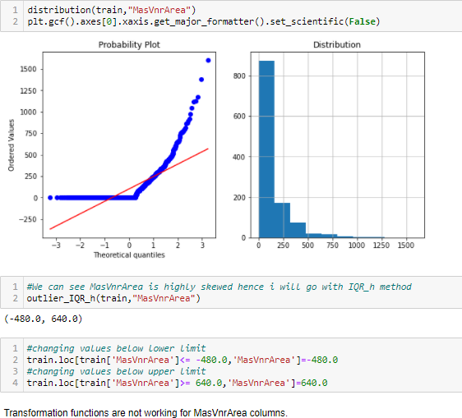

* TotalBsmtSF

•

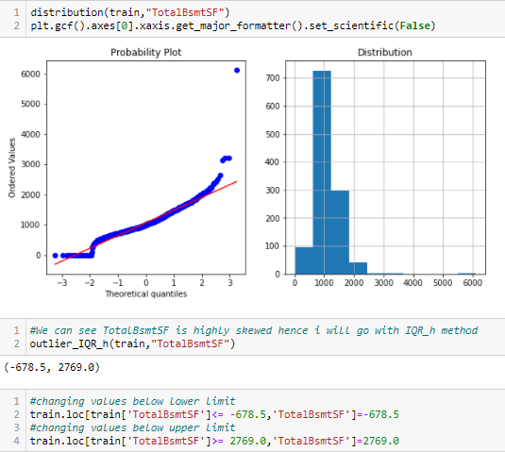

### GrLivArea

•

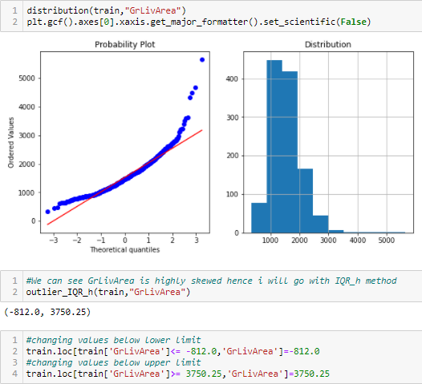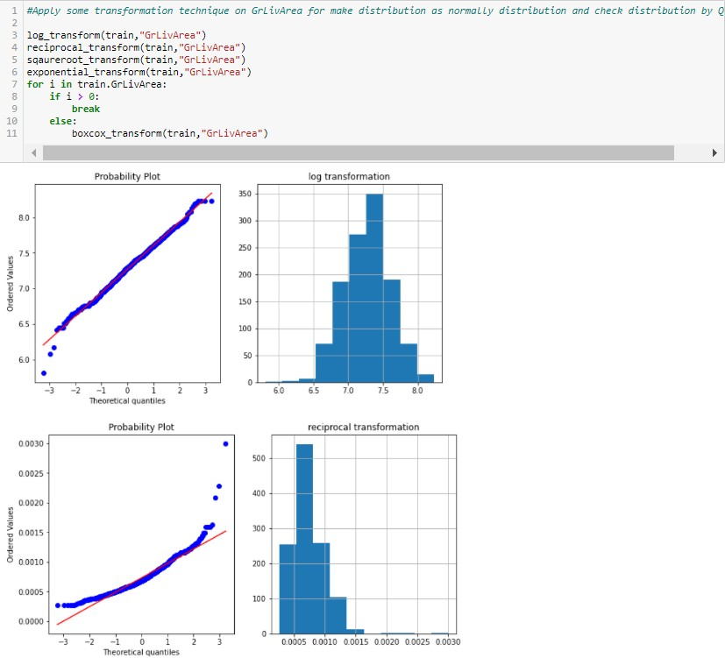

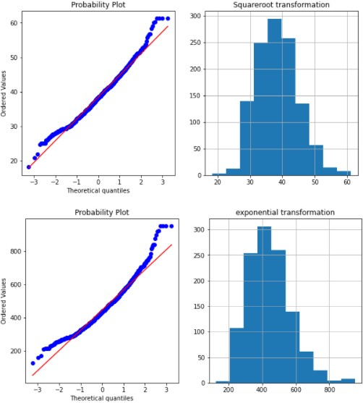

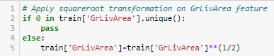

* GarageYrBlt

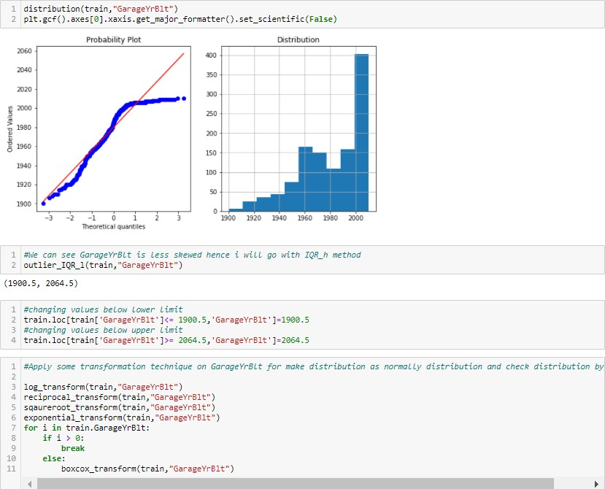

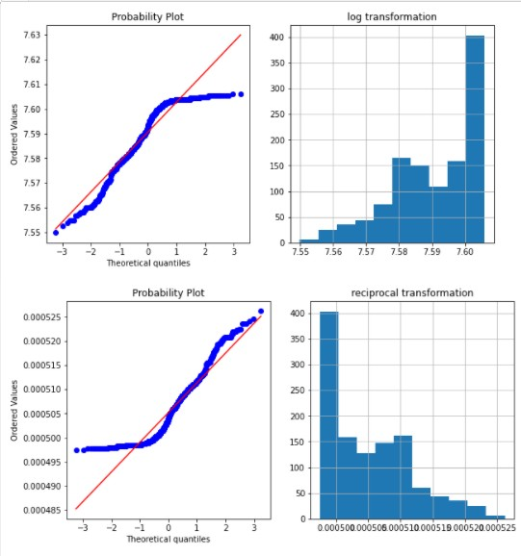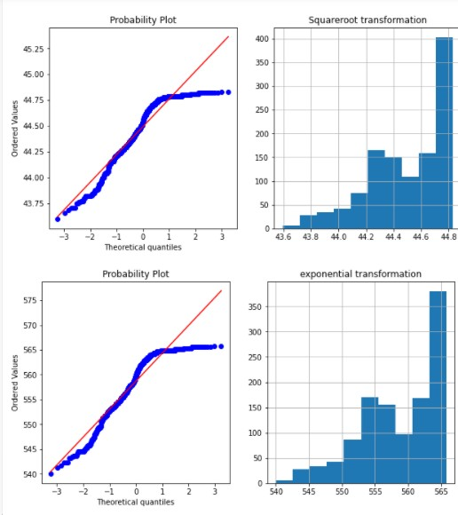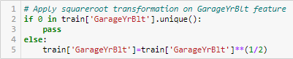

### GarageArea

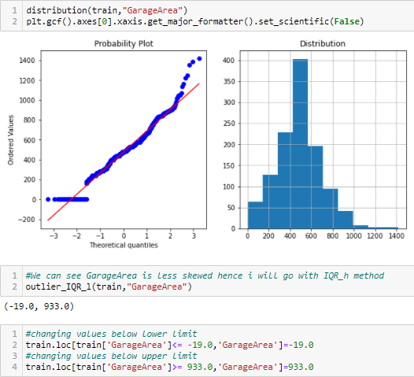•

### WoodDeckSF

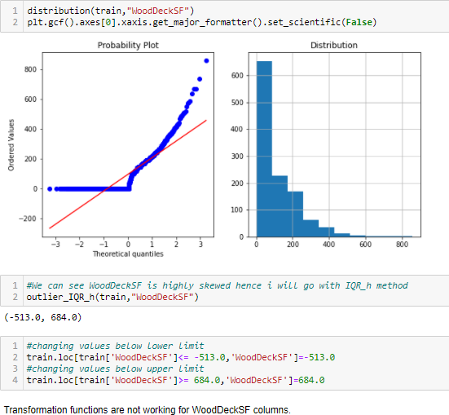

* **Remodelyrs**

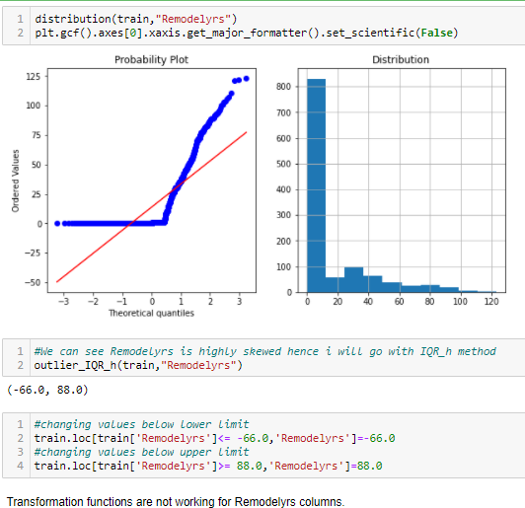

* **PropertyAge**

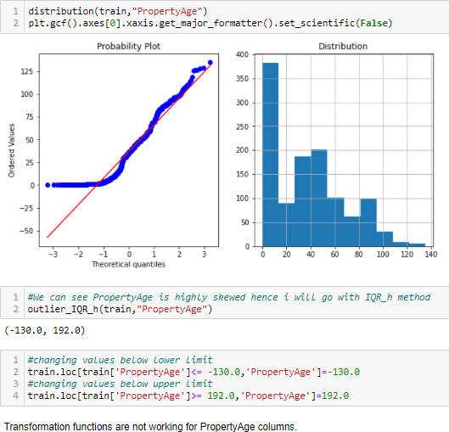

* **PPorch**

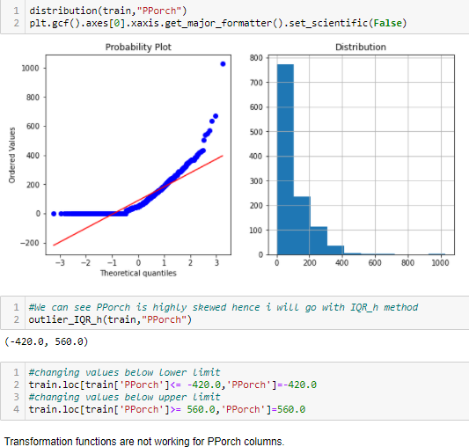

**Let's look at the correlation:**

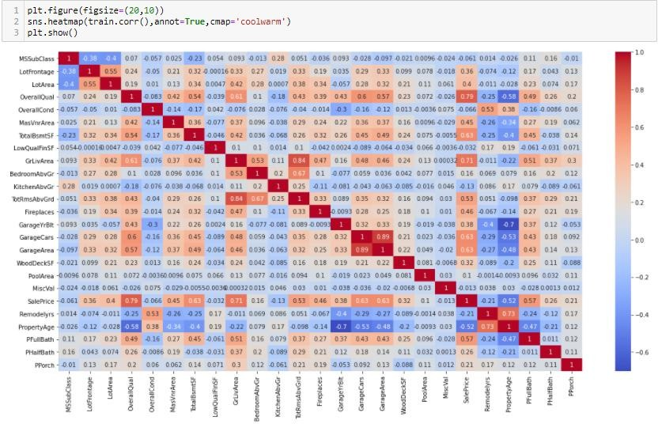

We need to check the correlation of all columns with or target column 'SalePrice' however where datatype of columns is Object hence we cannot see those columns.

Let's change the data type of other object type columns.

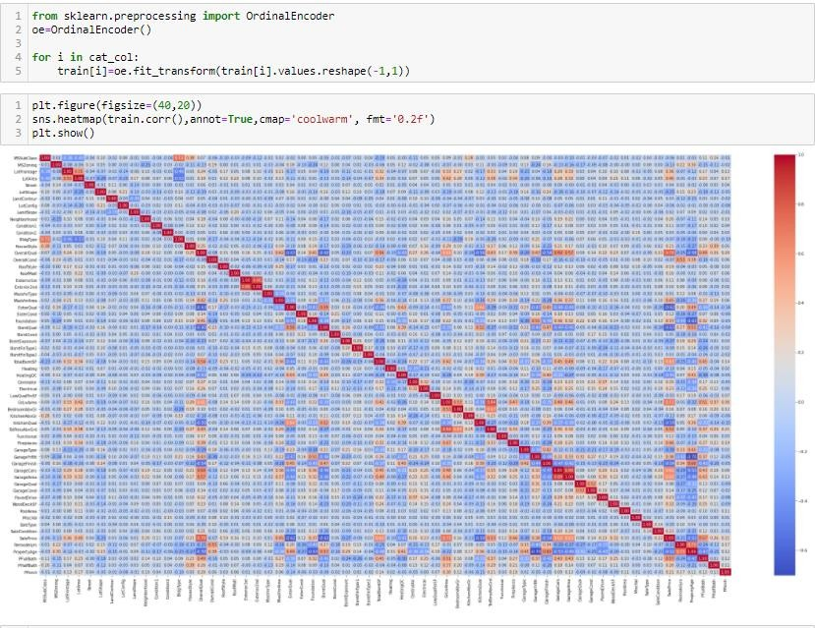

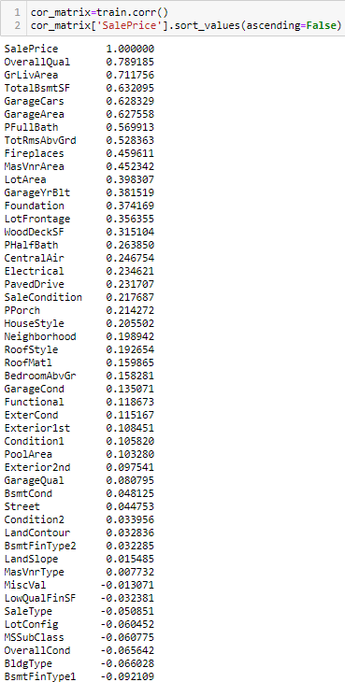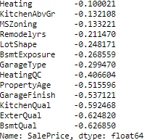

Below is the list columns has very less correlation with our target column, hence we can drop those.

BsmtCond Street Condition2 LandContour BsmtFinType2 LandSlope MasVnrType MiscVal LowQualFinSF



**Skewness and outliers removal:**

We have already delt with outliers.

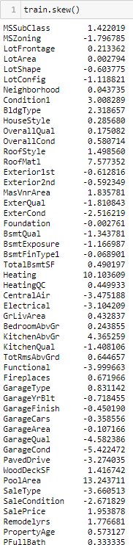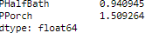

We do not consider skewness for target variable sales price and categorical and discrete variables.

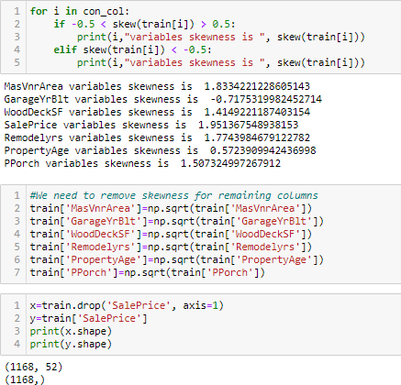

### Let's perform scaling now:



**We will import the test file now:**

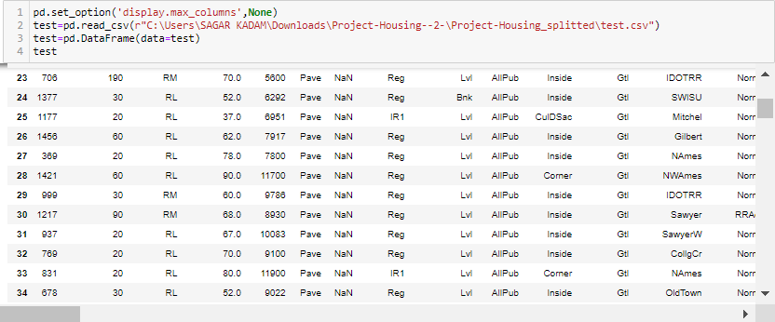

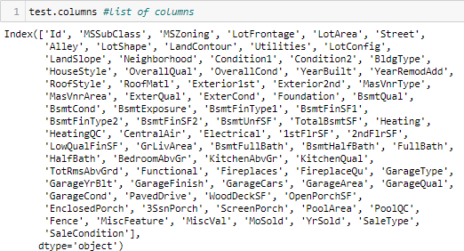

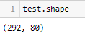

test dataset consists of 292 rows and 80 columns.

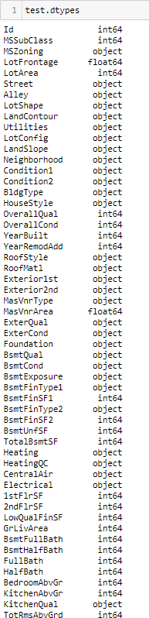

We can see both type of columns numerical and object type.

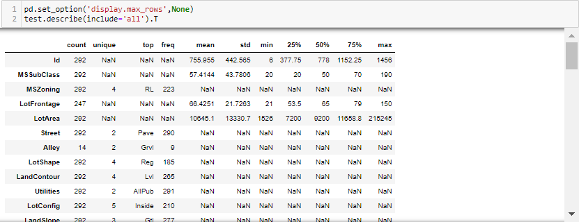

We can see count is all same for all variable, let's check for null values now:

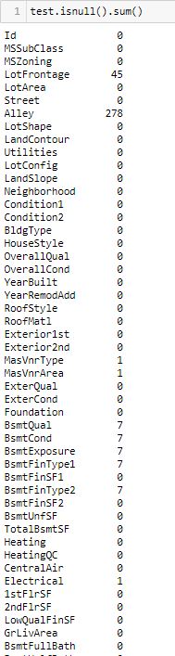 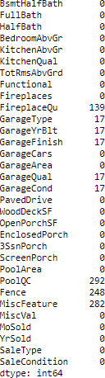

We can see null values in LotFrontage, Alley, MasVnrType, MasVnrArea, BsmtQual, BsmtCond, BsmtExposure, BsmtFinType1, BsmtFinType2, Electrical, FireplaceQu, GarageType, GarageYrBlt, GarageFinish, GarageQual, GarageCond, PoolQC, Fence and MiscFeature.

Dropping columns which has too many null values i.e. Alley, FireplaceQu, PoolQC, Fence, MiscFeature. Also we will be working on null values according to datatype of the particular column.

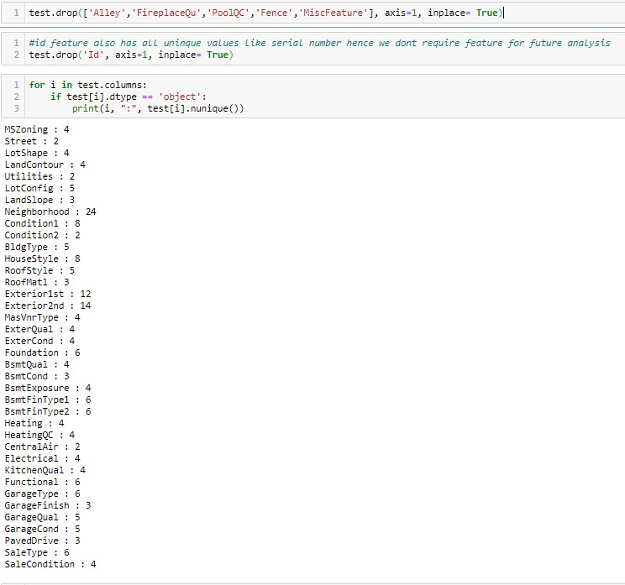

### let’s make a list of categorical columns first:

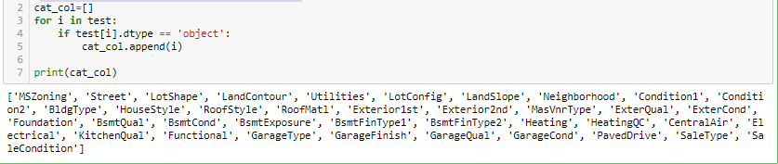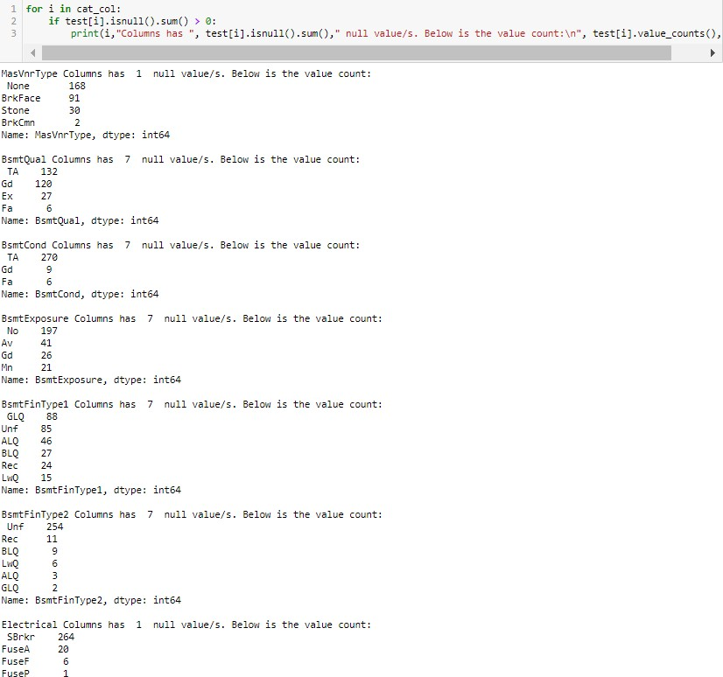

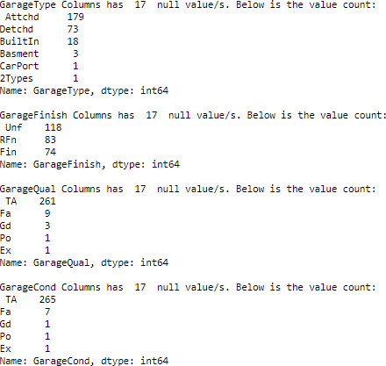

for i in cai_col:

* for i in test.columns[test.isuul]().any(aiis=0) : o test§i].filIna(test[i].mode()[0j,inplace=True)



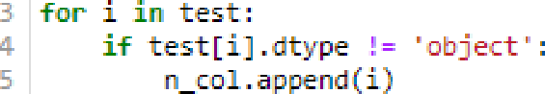

* print(n_col)

[ ’ fdss ubCla ss, '

Lot F *ronta ge*, '

*L at Are a ’* , *' Q•iera* \1Qua *\ ’* , ' 0^/eraI lCond, '

Yean BuiIt , ' Yea rRemodAd d ' , *' J'1a sYnrAre* a ’ , ’ Bsmt F in SFI ’ ,

'BsmtFinSF2', ’BsmtUnfSF', 'TotalBsmtSF', 'lstFlrSF', '2ndFlrSF', 'LovQualFinSF', ’GrLivArea’, 'B5mtFullBatt', ’BsmtHalfBath',

' FuII Bat h’ , ' Ha1f Bat h ’ , *°* Be *drooo b*v i*r '* , ’ Kit c henAbvGr ’ , *'* TotRmsAb'Jrd ' , ’ F i sepiac es, ' *’ 6 ara get* cB1\ ' , *’ Ga cageEa re ' ’ 6a ra genre*

a ’ , ’IdoodDec kSF, ’ ' Open Parc hSF ’ , ' E nc losedPouch ' , ’ 3Ss nPorc h ’ , ' Sc reenPor c h’ , *° Poo1Area ’ ,* ' I‘llscVaI ' , ’ NoS old ' , *’Yr5* old ' ]

dis_col=[]

1. con_col=[]

zf test [i ] . nunique ( ) < = 25 :

1. di s_c oI . append (i)

con_c oI . append (i)

ñ pri nt ( " L i>t cI z1 s c .°te z of b ua 1 s : " , d1s_co1, " ”'\n " )

? pri nt ( " L i>t cI to nt1 r ou * c oI u zn i s : " , con_c oJ )

List of discrete column is: ['DSSubC]as5', ’OverallQual’, ’OverallCond’, 'LowQualFinSF', 'BsmtFullBath', 'B5mtHalfBatt', ’FullB

ath ' , ’ HalfBath, ’

*Area’ ,* 'ñ\1scVa,l ’

' BedrocmAbvCsr ’, *'* Kit c henAbvGr ' , ’ TotRnsAbvGrd' , ’ F lreplaces ’, ' GarageCars *’ '* 3SsnPor ch ’ , ' Sc reenPorch ' , ' Pool ' HoSold ’ , *' Yr5o\d* ’ ]

List of Continous co]umn is: [’LotFrOntage’, 'LotArea', 'YearBuilt', ’YearRemodAdd', 'MasVnrArea', 'BsmtFinSFl’, ’BsmtFinSF2',

' BsctUnfS F, ’

losedPorch']

' TataIB snt SF ’ , ' 1st FInSF ' , ’ 2ndF1 rSF, ’

*' E r L ivhrea* ' , ’ GarageYrBl t ’ , *' 'fia ragei\rea* ’ , ’IdoodDec kSF, ’

' OpenPorchSF ’ , ' Enc

for i in con_co]:

2 if test[ij.isnull().sum())8:

print(i,"feature has “, test[i].isnu]l(}.sum(),"null ’'.'a.Les . ”)

2 for i in con_col:

o zf testi].isnuI().sum() 7 0:

- test{i].filIna(test[i].mean(),inp]ace=True)

test

Bg S SubCla ss HSZoning LotFrorrIa@e LotArea SJreet Lot Shape LandContour Utilities LotConfig Land Slope Neighborhood Condi€ion1 Condition2

0 20

120

2 20

TO B0 180

**180**

20

80

RL RL RL RL RL R K1

R k1 RL RL



fl0.D 581# Pave

60.0 118Z8 Pave

75.D 120D0 Pave

86.0 14508 Pave

21.D 1038 Ra\re



4D7.D 138B1 Pave

60.0 12800 Pave

IR 1



Reg Reg IR 1

Reg

Reg Reg Reg

HLS AJIPub Comer Lvl AllRub CuloSac Lv! AJIPub Inside Bnk AllRub

Lv! AJIPub CuloBac

Lvl AllRub

Lv! AJIPub Inside

Lvl AllRub

Low AJIPub Inside





Mod

StoneBr StoneBr



Craw”for



Edwards mddglt SawyerW

Elcvm



Norm



Feed r



Norm



Norm

Wom



Tom



Tom



Tom



Tom

120

R K1

Reg

Lvl AllRub

FR2



I lets find out out *Ltie di f-f-erenc e year bud Ld and reeode I*

test[ ' Renoze.\ -s ' ] =test[ '”Nez -3ezo&.dc!" ] -test [ "YeanBc1.I " ]

0 £ets find out o/ o9e o/ *proper Iy* i . e . *year* bu i £ d - *VrSoL d*

test[ ’ drop.=n-\ Age ’ ]=test[ id” ] -test [ "YeanB ui Lt " ]

0 £ eI ’z *drop the* co £ omns lull T ct one nof *required for further* ono Sys T s

I est . drop ( [ ’ YeanB ui Lt ’ , ' Yea rRe zoc Act d ’ , ' I bS o1z ’ , ' YnSc let ’ ] , a xi s =I, in p1a ce= True)

*# Togo LBsntSF —— Be.nLF inSF1 + Bs*r /*tF inSF2 + BsntLln F- hence we can drop other 3 co L urns*

test .drop( [ ’ 3*rt'znSFl ' , ' 6srrt FinS'2 ’ , ' B s z- UnfSF ' ] , ax1s=1, in place = True)

*# GrL i vAreo —— 1stFtrSF- + 2ndF L rSF hence tm can drop other' 2 uar i ob L es*

test.'d* ro” p' ( [ ’ J*IF 1r SF ’ , ' 2az' I rSF ’ ] , axis=1, i npJace= True)

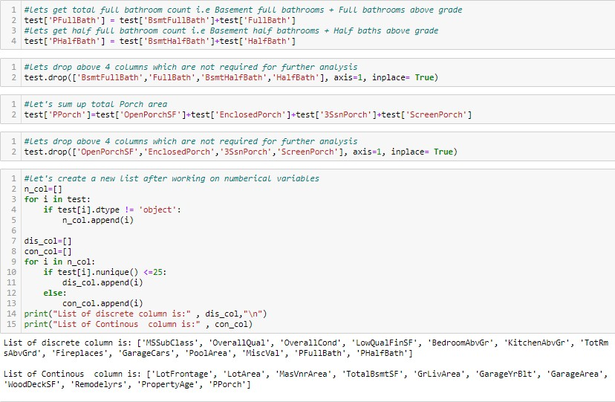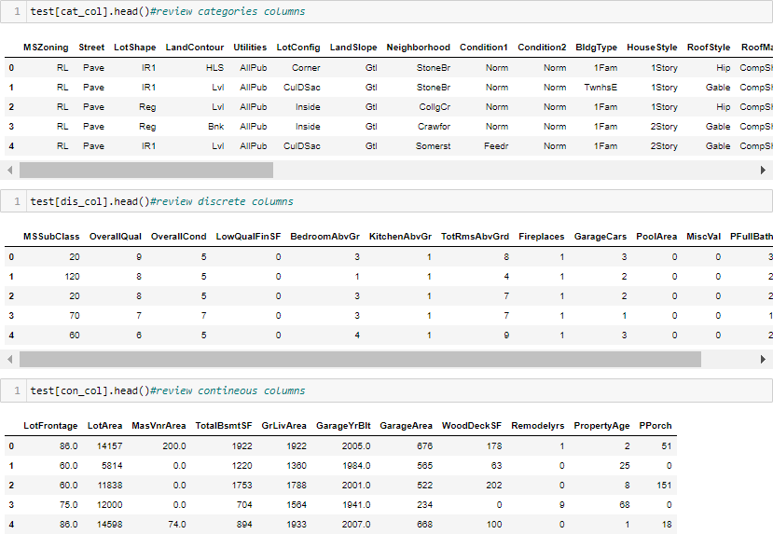

# Visualization:

fOF 1 lM Cat_COl:

pJt .figure(f1gsTze=(8,6 ) ) a=sns . countp1ot(test [1] ) print (test[ i] . vaIue_c ount s ( ) }

a . set_xt:ickIabeJs ( a . get_xt ie k1abe Is ( ) , rotat1on=9^, ha= ”' :igat " }

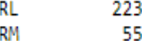FV 13

T’.are: ".S Zonikg, d-;'pe: int64

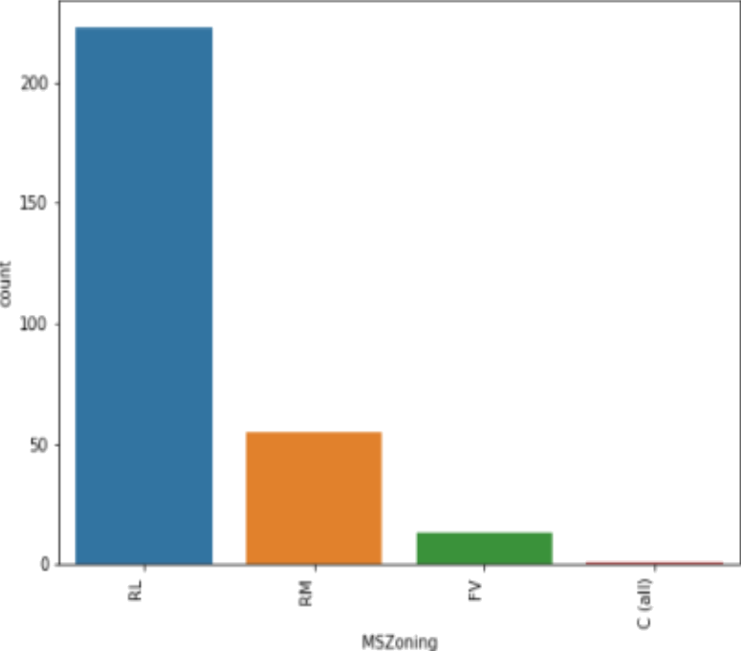

°a'.'e 296

Gr.'I 2

T.are: Stre.°t, dt; pe: intfi^

Reg 2 BS

I RI 94

IR2 9

IR3 4

Name: LotShape , dt}’pe: i nt64

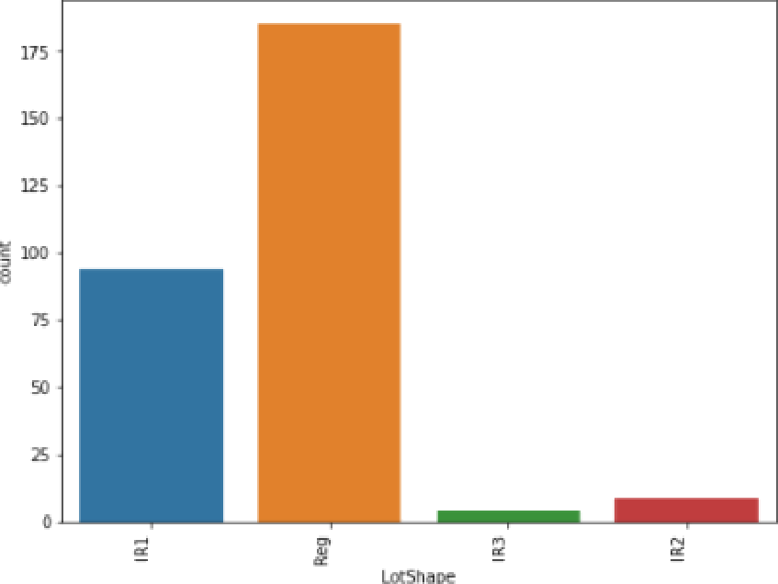

265

TLS 8

Low 6

Name : LandContour , dt,'pe : int64

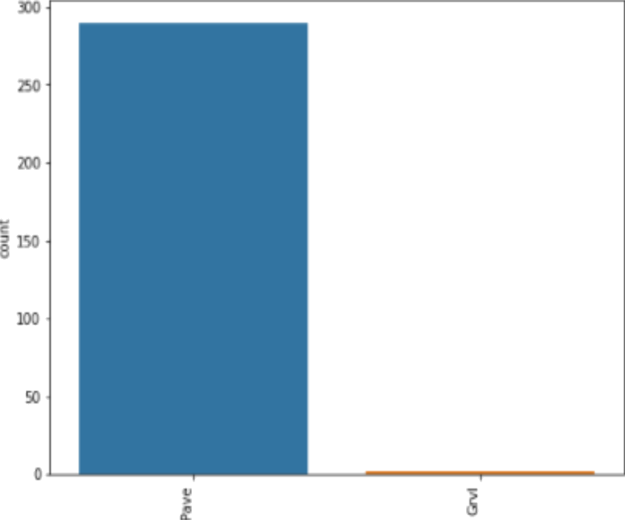 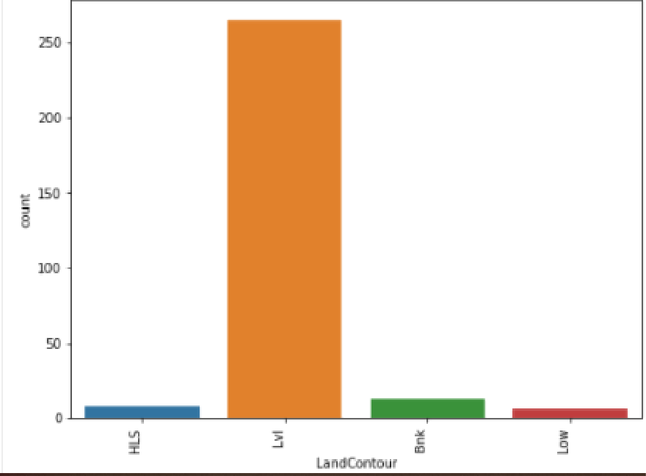

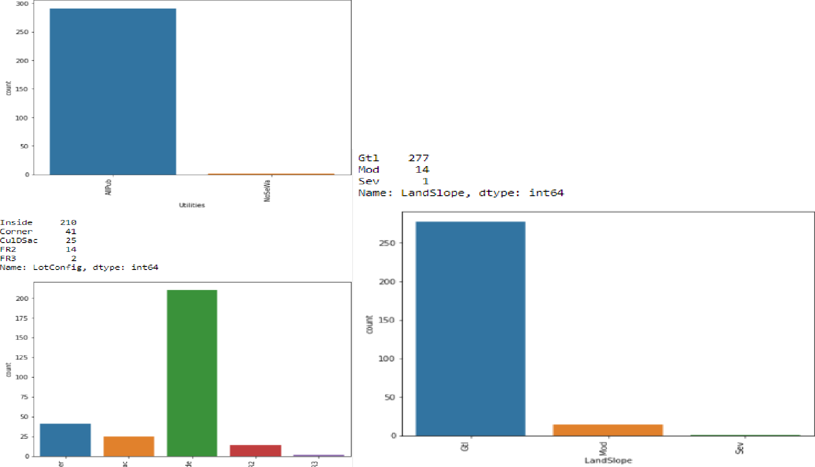









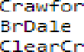

snlsu

 

KPkVill ’l

f,o“n 291

RRf'Jr 1

I, arr .° : Cc r d it'on2, dt,•pe : int6^

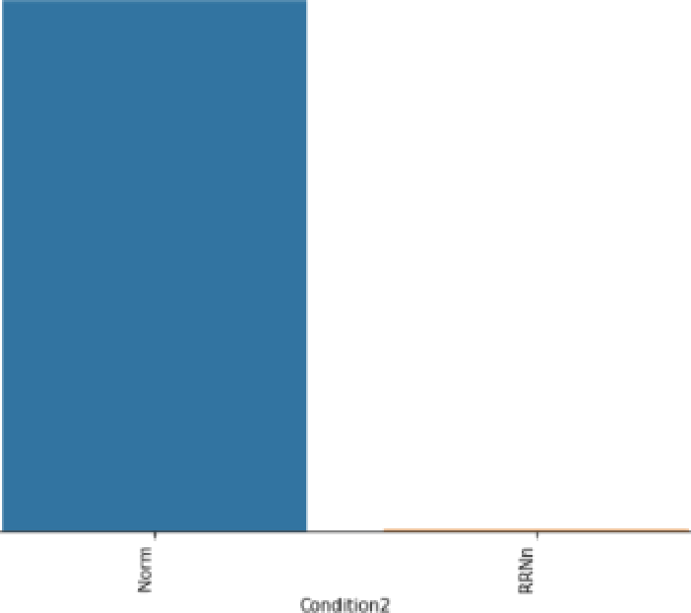

lFam 239

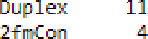

Fees’ 1^

fi.rt.°" 1°

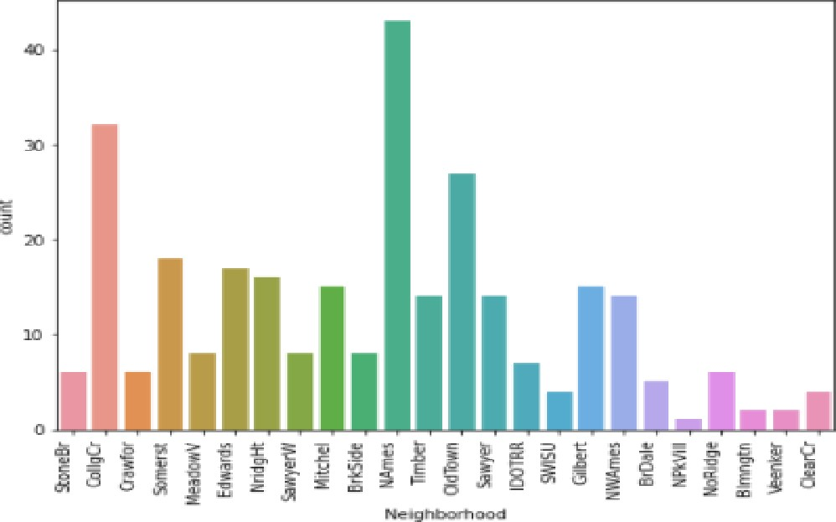1RAr é

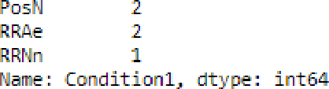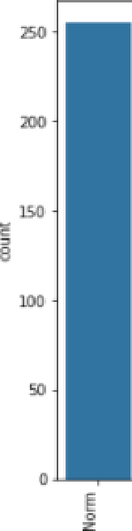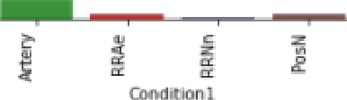

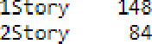

SL.'1 18

SFoyer 5

1.5Unf 2

2.5Fiu 1

* 1. Unf 1

f,are: Hc&seS:yle, dtype : int6^

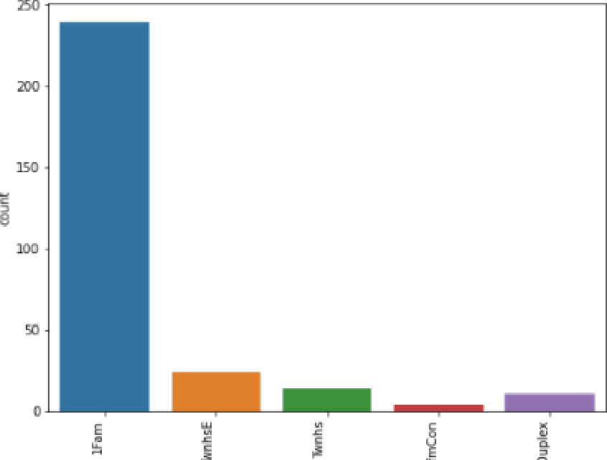 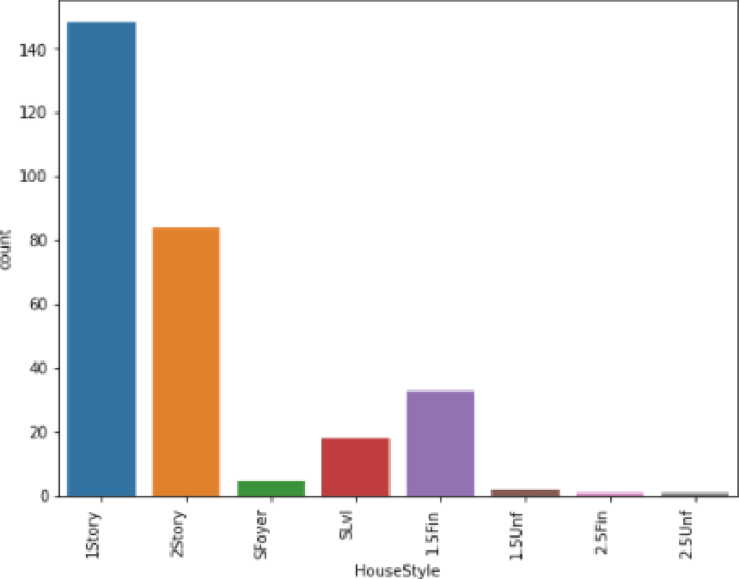

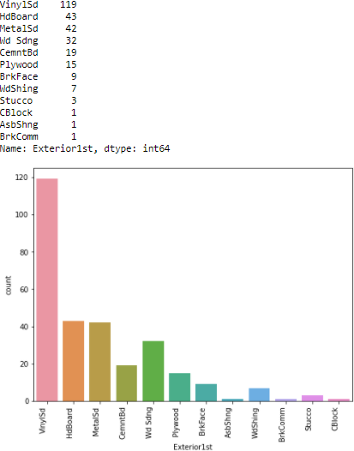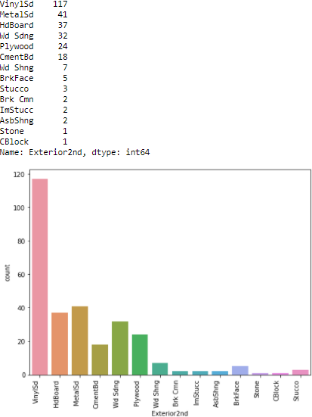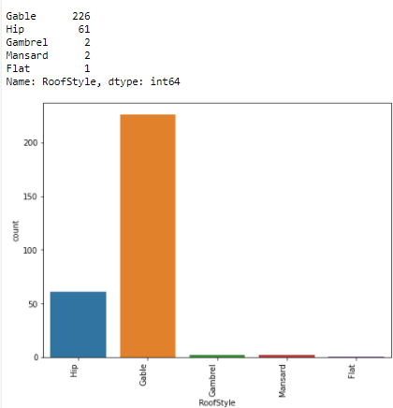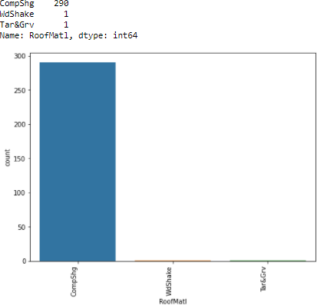

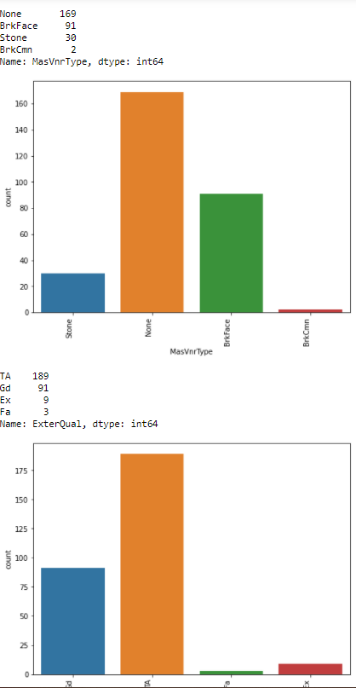 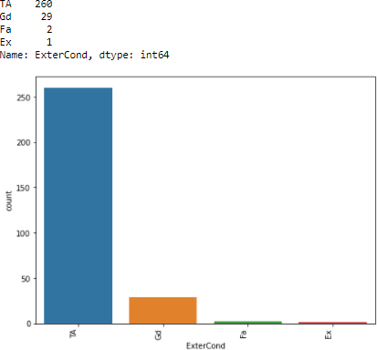

|  |  |  |  |
| --- | --- | --- | --- |
| PConc | 134 |  | |
| BrkTil | 34 |
| Slab | 3 | TA | L39 |
| Stone |  | Ex | 27 |

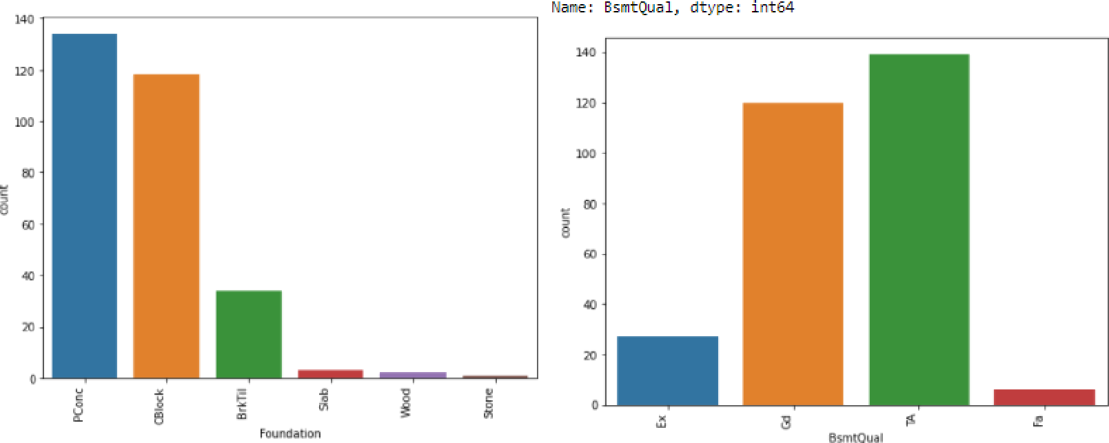

TA 277

Gd 9

Nane: BsetCond, dtype: int64

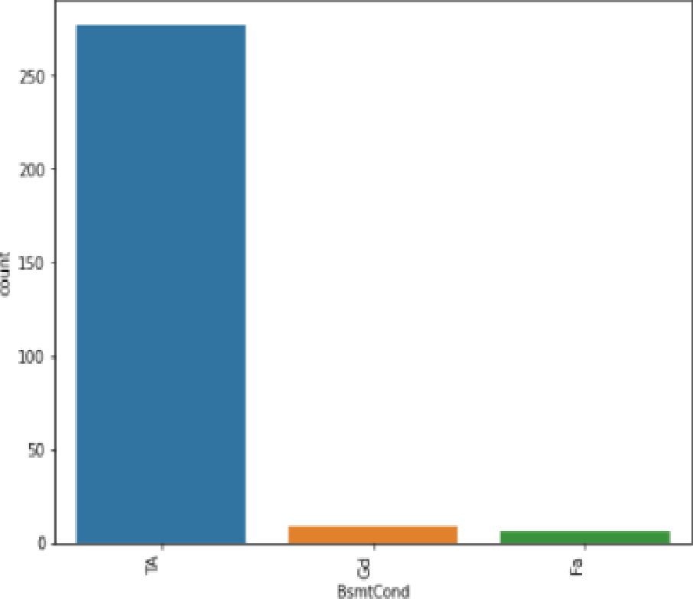

No 294

No 2B4

Au 41

Nn Z1

Nane: Bsrrt Exposure, dtype: 1nt64

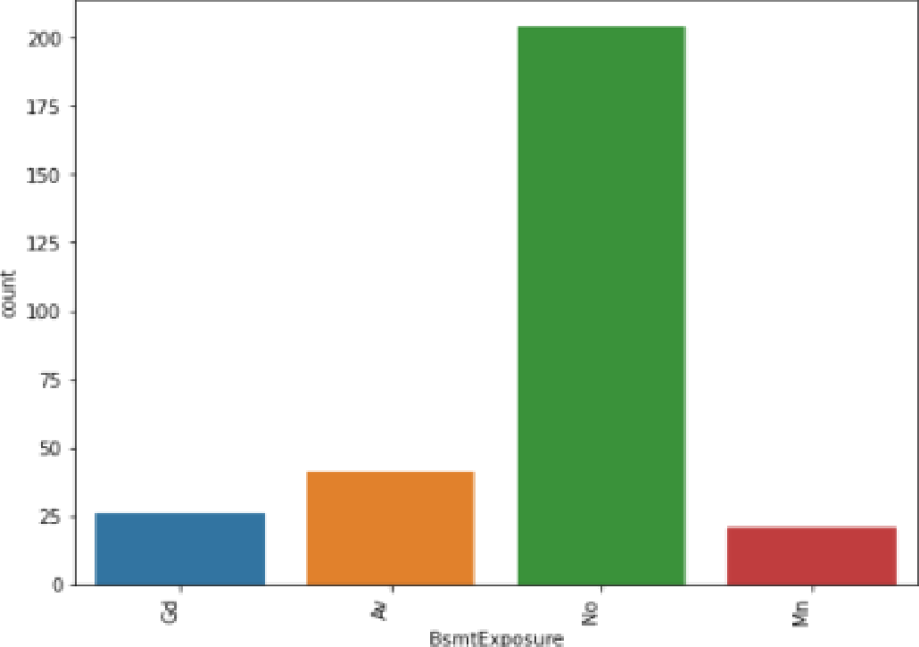

GLQ 95

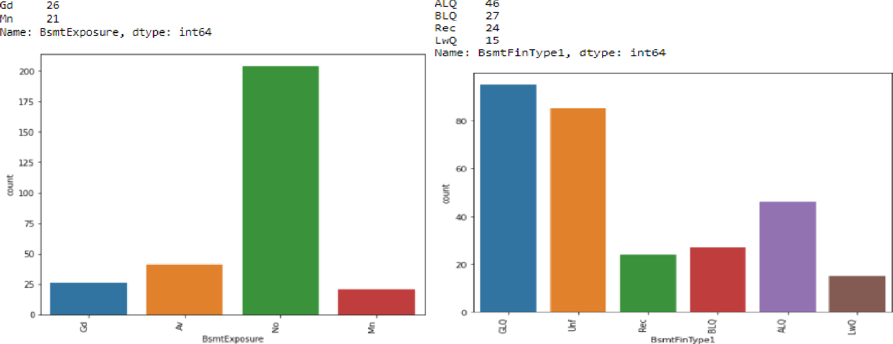

|  |  |
| --- | --- |
| LnT | 261 |
| Dec | 11 |
| 3LQ | 9 |
| GLQ | 2 |

Nare: bsmtFiaType2, :t,pe: in:64

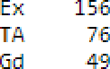

'J1

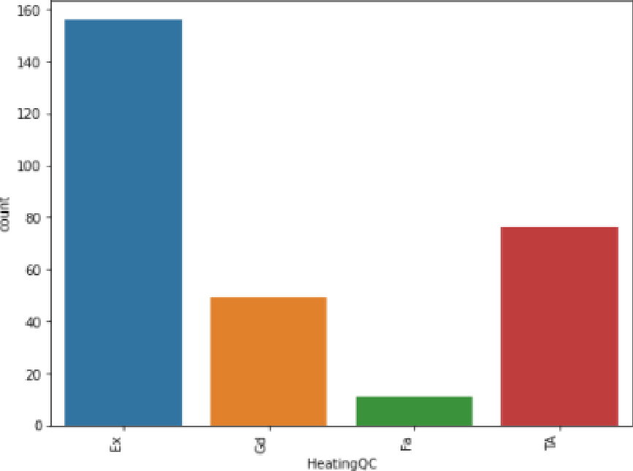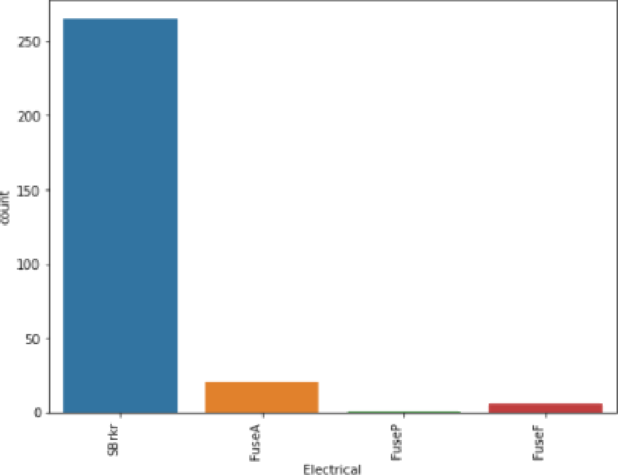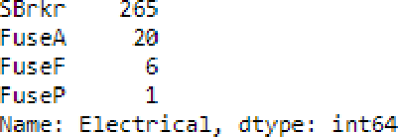fl,az.• : He aI inggC, rIt^'pe: rt64

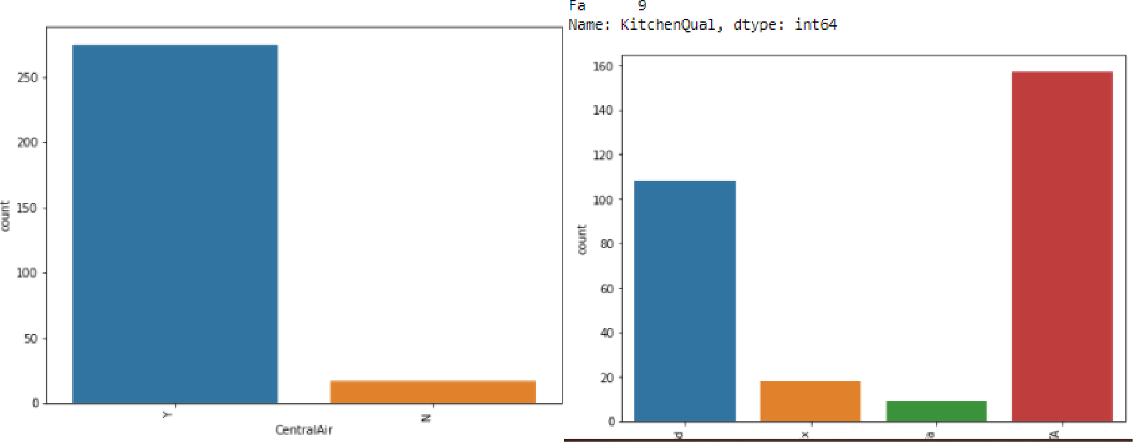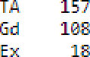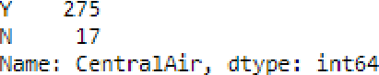

Typ 275

Mini 6

MlM2 4

Nod J

Majl J

Naj2 1

Nane: Functiona 1, dtype: int64

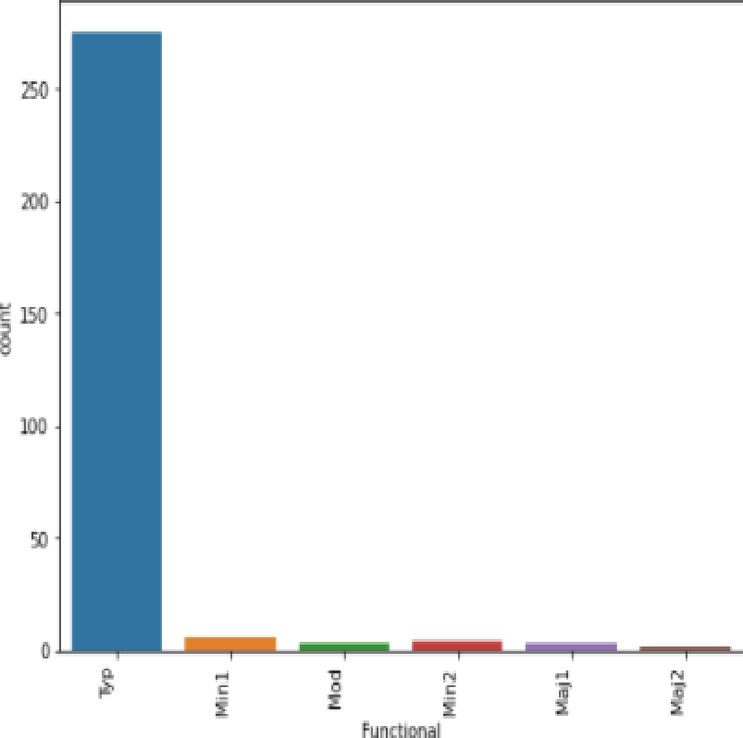

RFn 83

Fix 74

Fa 7

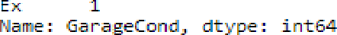Pa 1

Attchd 196

Detchd 73

Bu:iltln IB

Basment 3

EarPort 1

2Types 1

Name: Ga rageType, dtype: int64

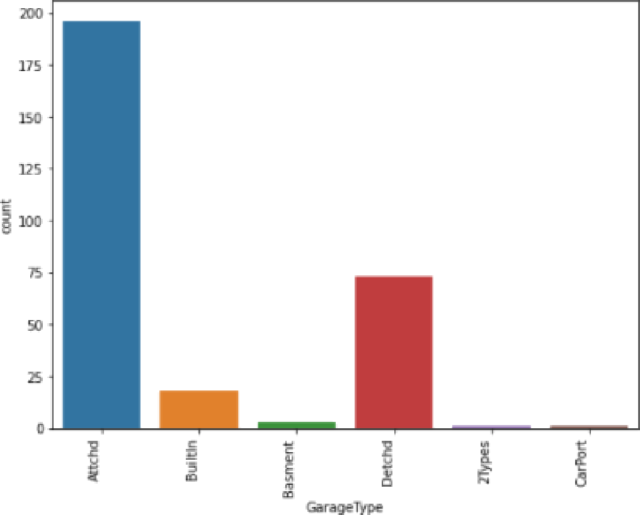

TA 27B

Fa 9

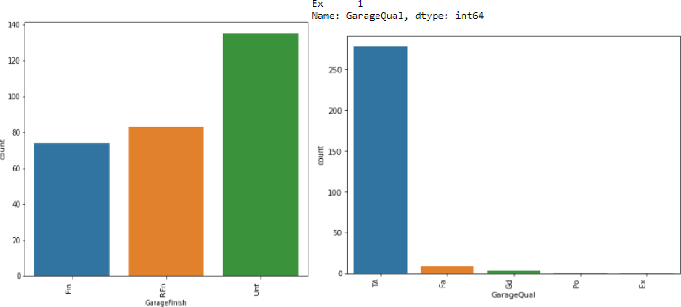

Naee: Garages inish, dtype: int64



N 16

Name: PavedDrive, dtype: int64

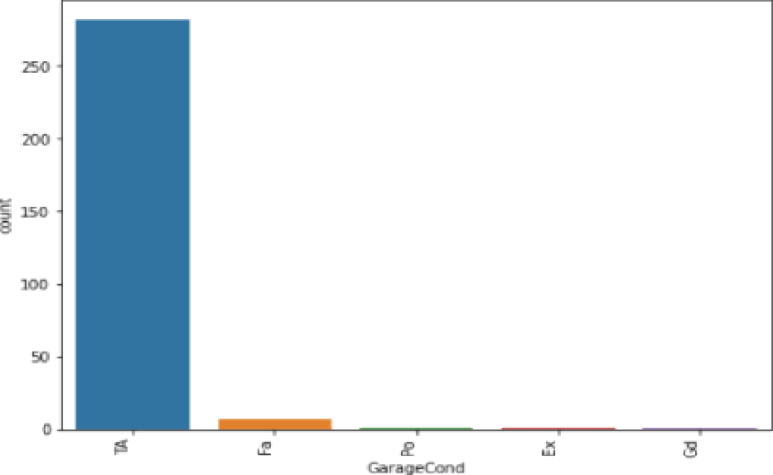 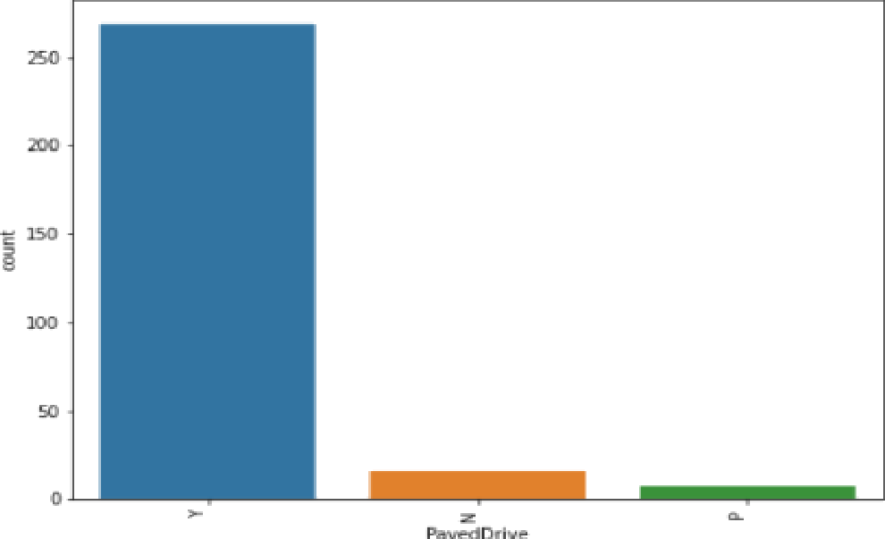

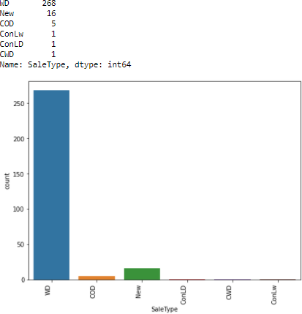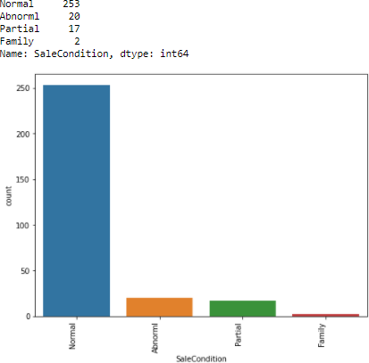

### Observations:

* + 1. In MSZoning, highest count is for RL and lowest is for C(all).
    2. For pave street, highest count is for Pave and Grvl is the lowest.
    3. For Lot shape, highest count is for Reg and lowest is for IR3.
    4. For LandContour, highest count is for Lvl and lowest is for Low.
    5. With respect to Utilities, highest count is for AllPub and lowest is for NoSeWa.
    6. With respect to LotConfig, highest count is for Inside and lowest is for FR3.
    7. For LandSlope, highest count is for Gd and lowest is for Sev.
    8. With respect to Neighborhood, highest count is for NAmes and lowest is for NPKill.
    9. With respect to Condition1, highest count is for Norm and lowest is for RRNn.
    10. With respect to Condition2, highest count is for Norm and lowest is for RRNn.
    11. With respect to BldgType, highest count is for 1Fam and lowest is for 2fmCon.
    12. With respect to HouseStyle, highest count is for 1Story and lowest is for 2.5Fin, 2.5Unf.
    13. With respect to RoofStyle, highest count is for Gable and lowest is for Flat.
    14. With respect to RoofMatl, highest count is for CompShg and lowest is for Tar&Grv, WdShake.
    15. With respect to Exterior1st, highest count is for VinylSd and lowest is for CBlock, AshShng and BrkComm.
    16. With respect to Exterior2nd, highest count is for VinylSd and lowest is for CBlock,Stone.
    17. With respect to MasVnrType, highest count is for None and lowest is for BrkCmn.
    18. With respect to ExterQual, highest count is for TA and lowest is for Fa.
    19. With respect to ExterCond, highest count is for TA and lowest is for Ex.
    20. With respect to Foundation, highest count is for PConc and lowest is for Stone.
    21. With respect to BsmtQual, highest count is for TA and lowest is for Fa.
    22. With respect to BsmtCond, highest count is for TA and lowest is for Fa.
    23. With respect to BsmtExposure, highest count is for No and lowest is for Mn.
    24. With respect to BsmtFinType1, highest count is for GLQ and lowest is for LWQ.
    25. With respect to BsmtFinType2, highest count is for Unf and lowest is for GLQ.
    26. With respect to Heating, highest count is for GasA and lowest is for OthW.
    27. With respect to HeatingQC, highest count is for Ex and lowest is for Fa.
    28. With respect to CentralAir, highest count is for Y and lowest is for N.
    29. With respect to Electrical, highest count is for SBrkr and lowest is for FuseP.
    30. With respect to KitchenQual, highest count is for TA and lowest is for Fa.
    31. With respect to Functional, highest count is for Typ and lowest is for Maj2.
    32. With respect to GarageType, highest count is for Attchd and lowest is for 2Types, CarPort.
    33. With respect to GarageFinish, highest count is for Unf and lowest is for Fin.
    34. With respect to GarageQual, highest count is for TA and lowest is for Ex,Po.
    35. With respect to GarageCond, highest count is for TA and lowest is for Gd,Ex and Po.
    36. With respect to PavedDrive, highest count is for Y and lowest is for P.
    37. With respect to SaleType, highest count is for WD and lowest is for ConLD,CWD and ConLw.
    38. With respect to SaleCondition, highest count is for Normal and lowest is for Family.

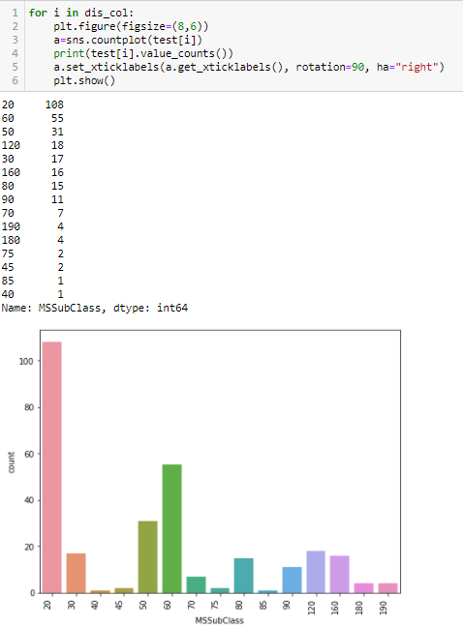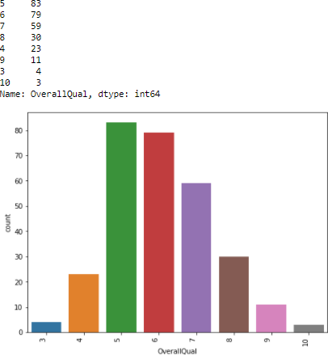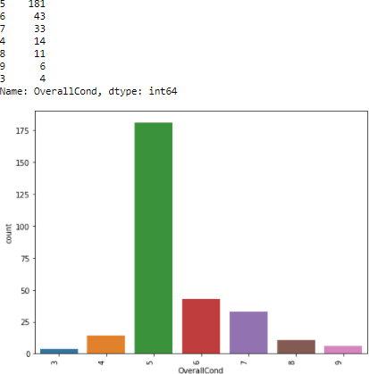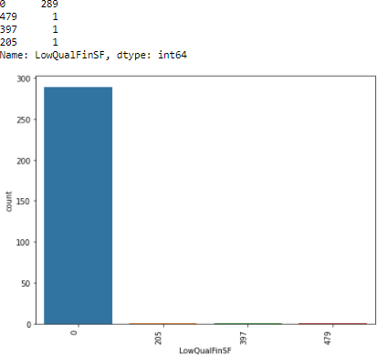

3 J64

2 77

1 lJ

6

Nane: Be drooWbvGr, dtype: int64

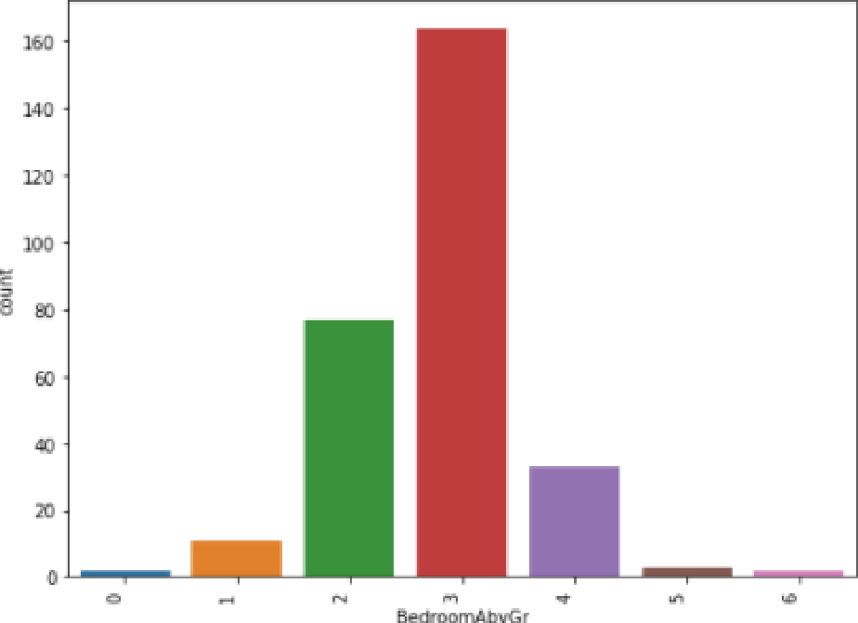

6 77

7 61

5 5%

8 39

4 25

9 10

20 6

6

22 5

278



Nane: K'ttc henAbvl2 rv dtype: int64

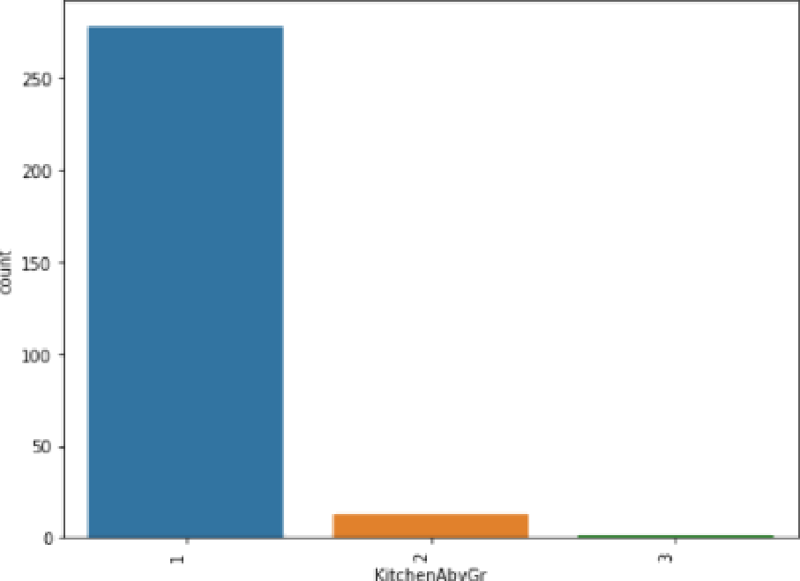

0 ]39

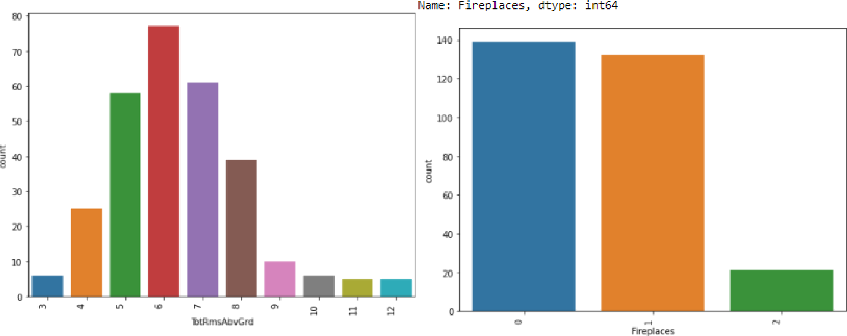

21

5

Name: TotRmsAbvGrd, dtype: int64

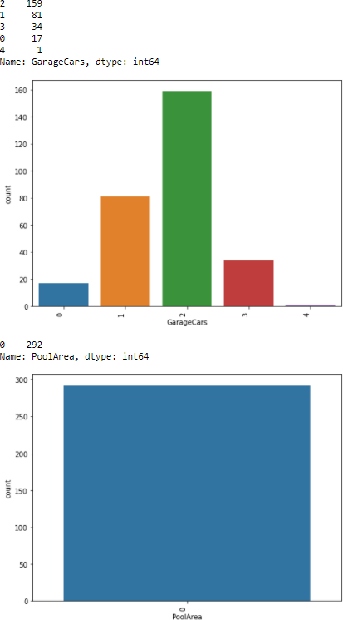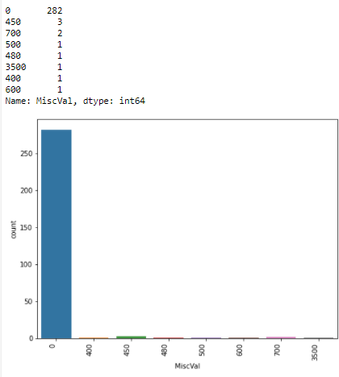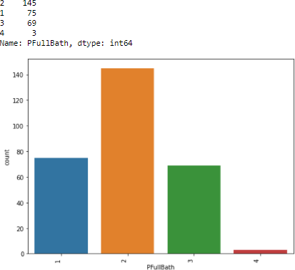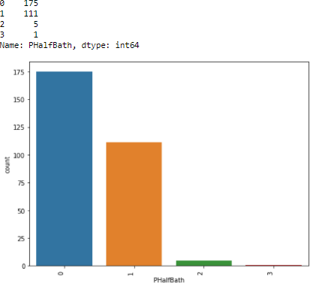

### Observations:

1. In MSSubClass, highest count is for 20 value and lowest is for 85,40 value.
2. For OverallQual, highest count is for 5 value and Grvl is the 10 value.
3. For OverallCond, highest count is for 5 value and lowest is for 3 value.
4. For LowQualFinSF, highest count is for 0 value and lowest is for 205,479,397 value.
5. With respect to BedroomAbvGr, highest count is for 3 value and lowest is for 6,0 value.
6. With respect to KitchenAbvGr, highest count is for 278 value and lowest is for 3 value.
7. For TotRmsAbvGrd, highest count is for 6 value and lowest is for 12, 11 value.
8. With respect to Fireplaces, highest count is for 0 value and lowest is for 2 value.
9. With respect to GarageCars, highest count is for 2 value and lowest is for 1 value.
10. With respect to PoolArea, only one value 0.
11. With respect to MiscVal, highest count is for 0 value and lowest is for 500, 480,3500,400 and 600 value.
12. With respect to PFullBath, highest count is for 2 value and lowest is for 4 value.
13. With respect to PHalfBath, highest count is for 0 value and lowest is for 3 value.

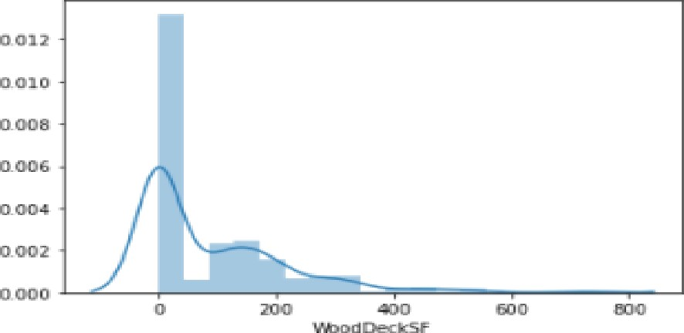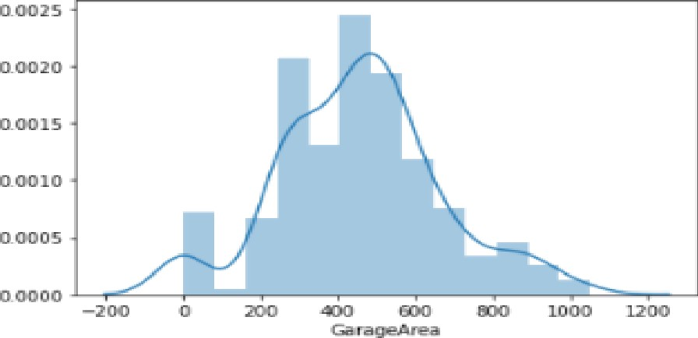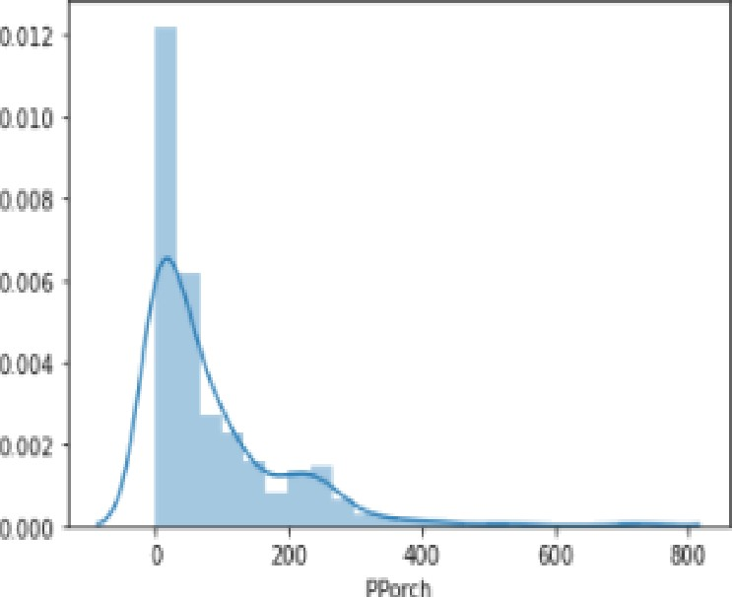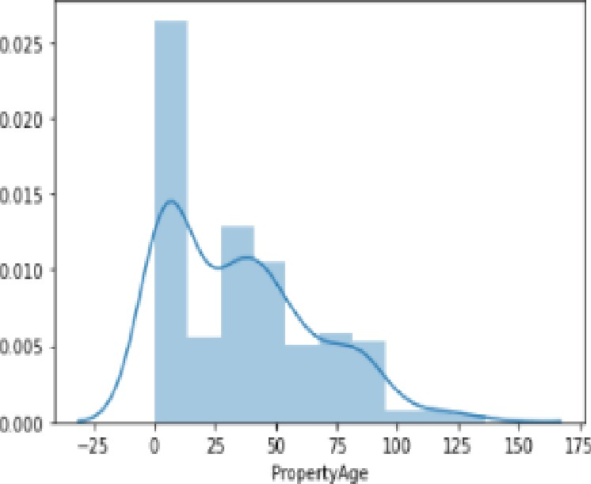-For i In con_co I :

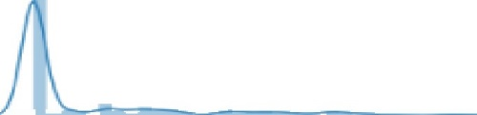

0.G 2 S

lT0

< pJt .-Figure( )

s n s . di stp lot (I est [ i ] , kde =True)

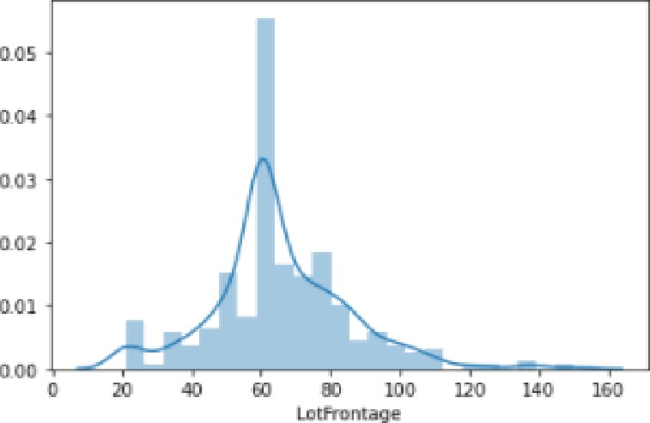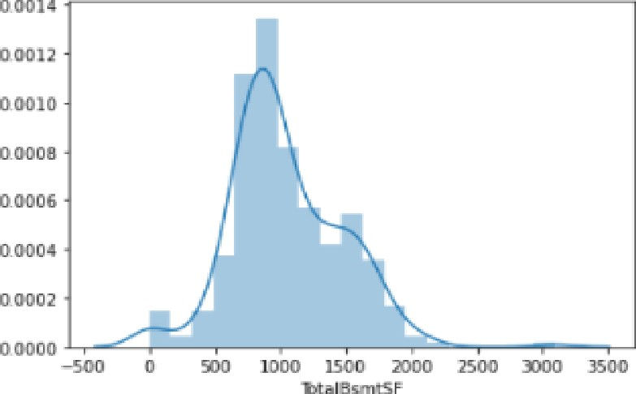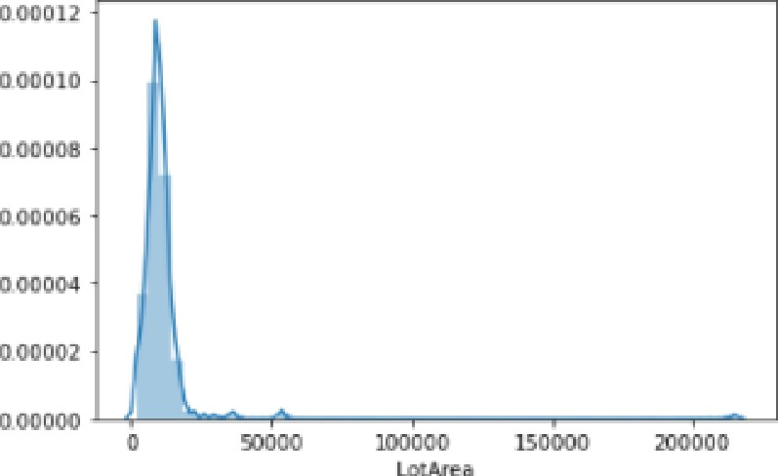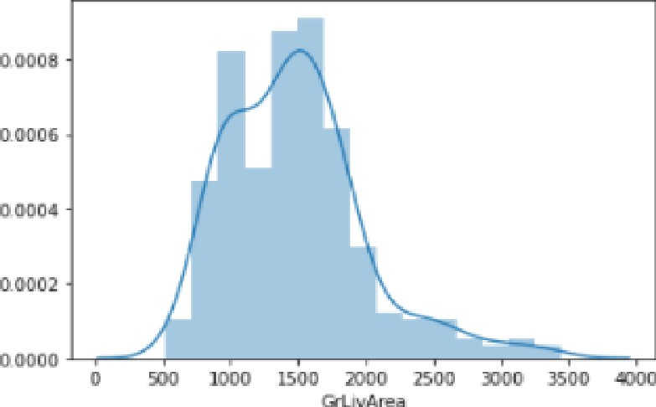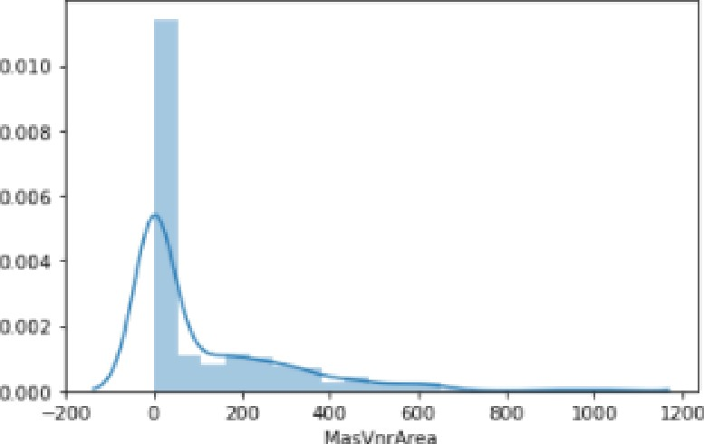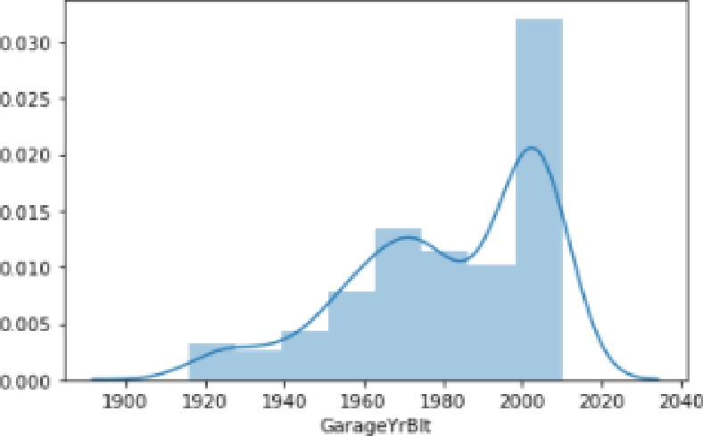

We can see for numerical columns data is not evenly distributed.

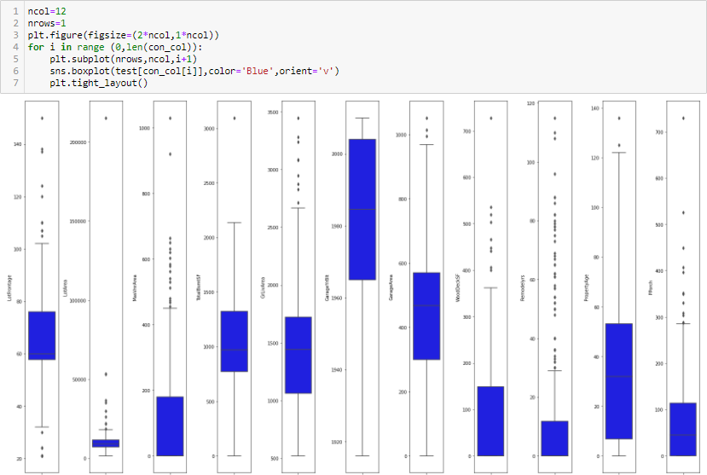

We can see outliers in all numerical variables.

### Let's Work on features individually

* **LotFrontage**

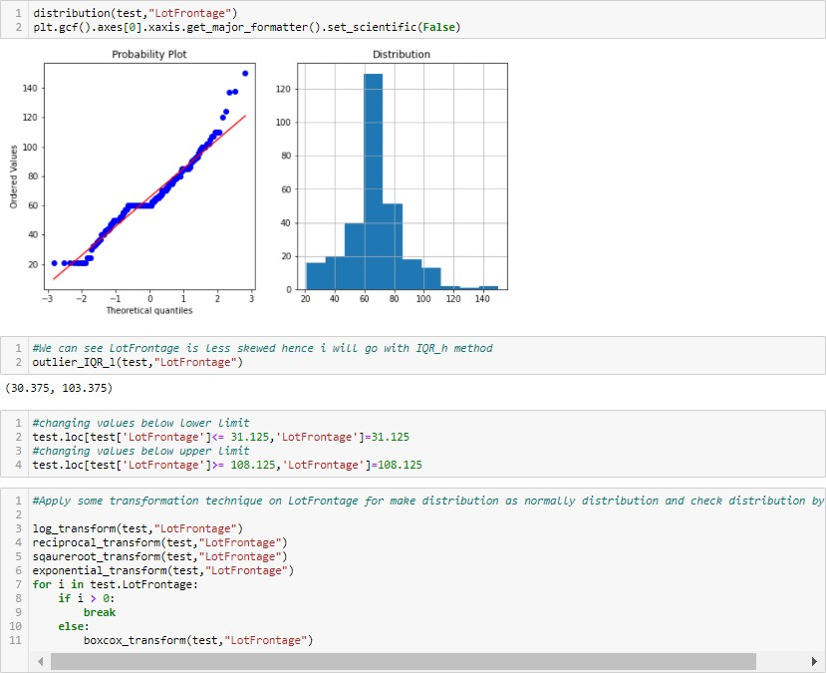

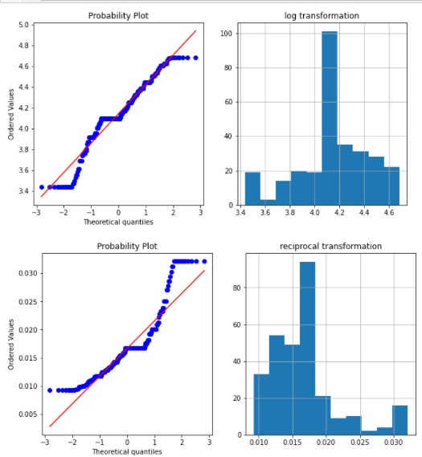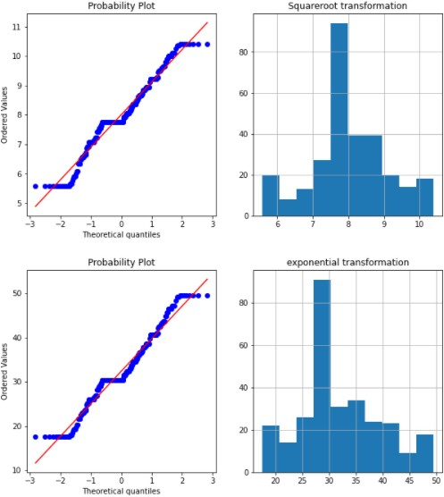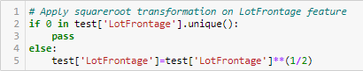

* **LotArea**

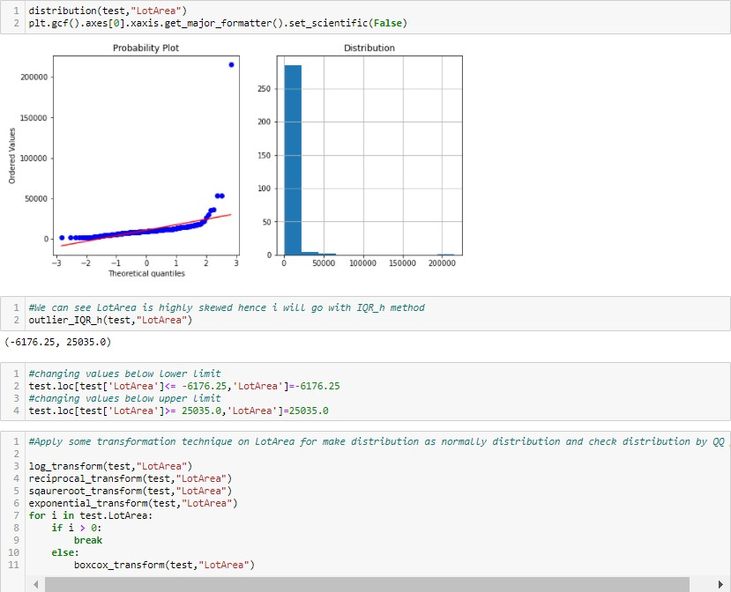

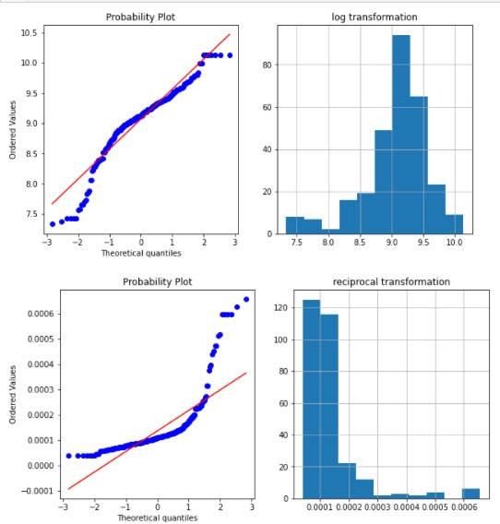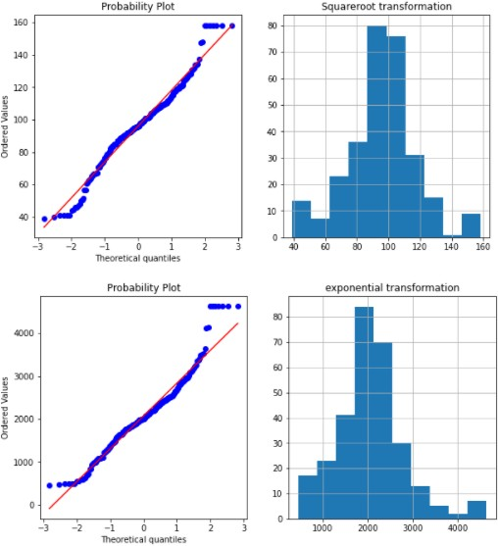

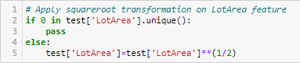

* **MasVnrArea**

•

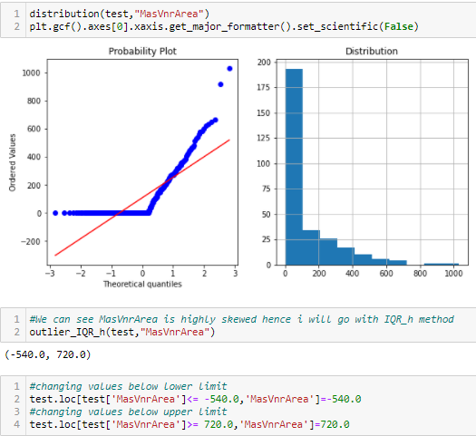

Transformation functions are not working for MasVnrArea column.

### TotalBsmtSF

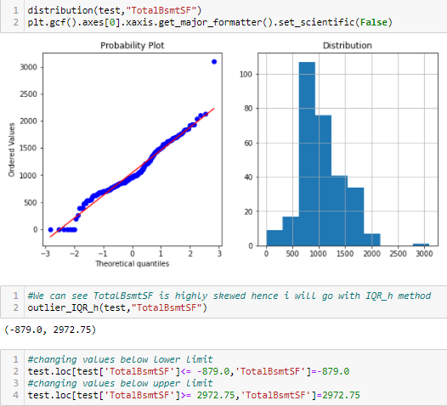

* **GrLivArea**

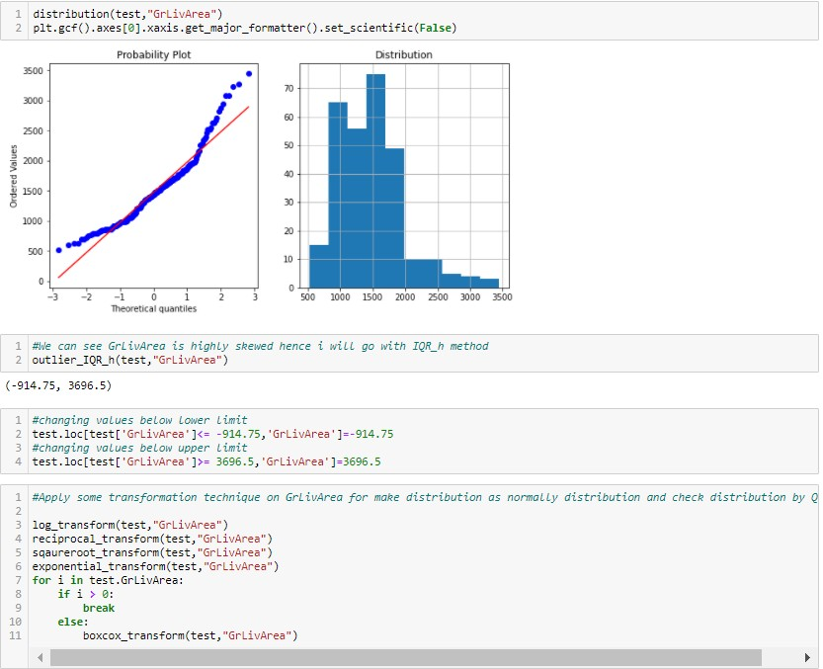

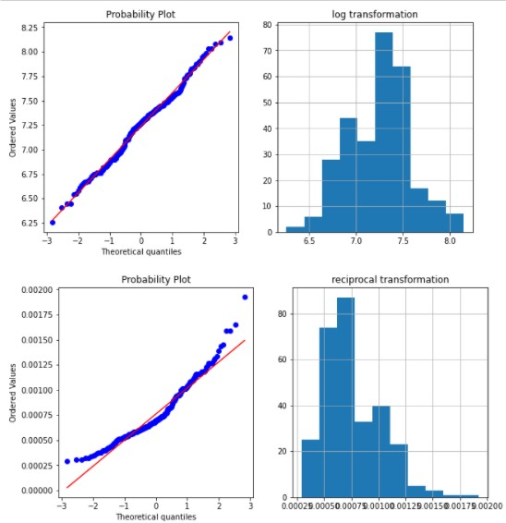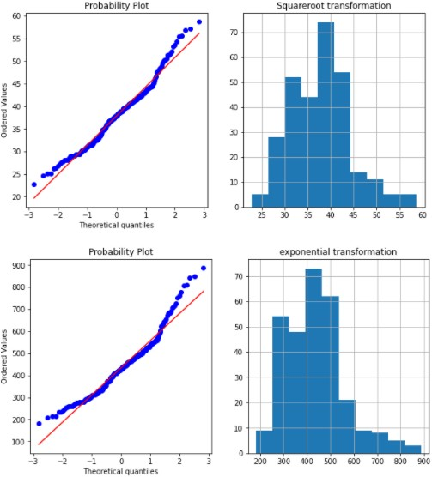

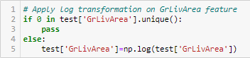

* GarageYrBlt

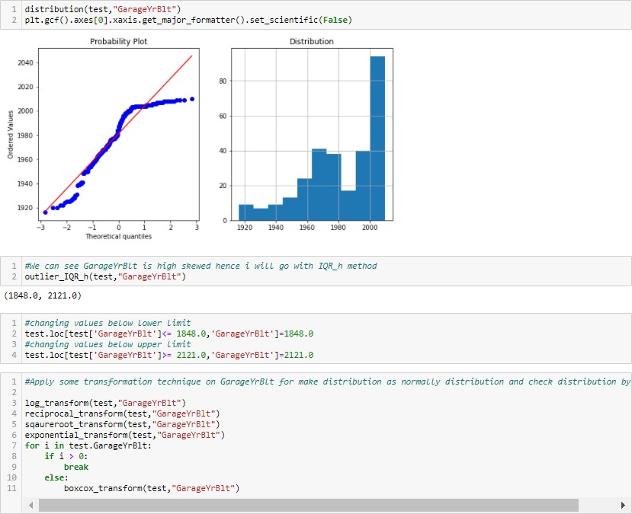

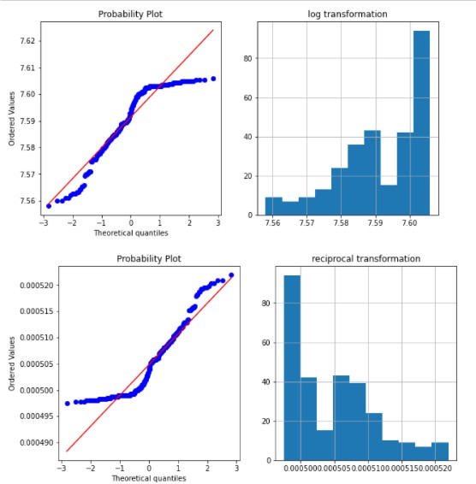 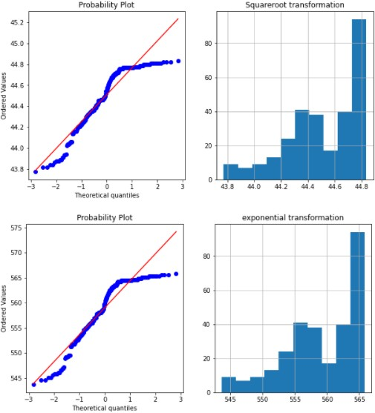

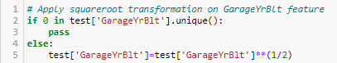

### GarageArea

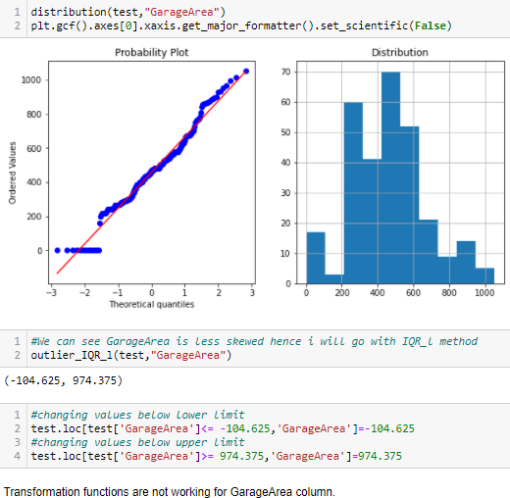

* **WoodDeckSF**

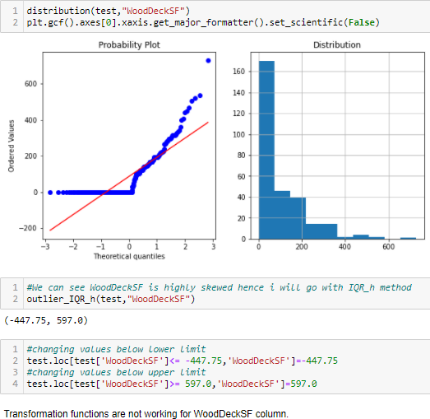

* **Remodelyrs**

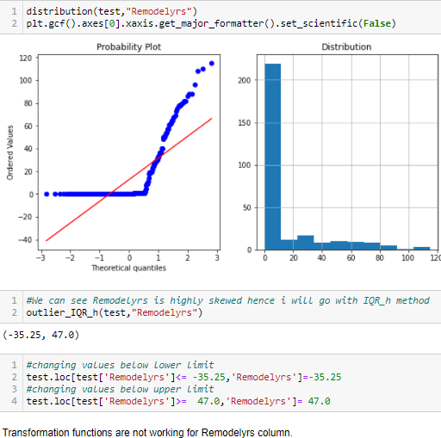

* **PropertyAge**

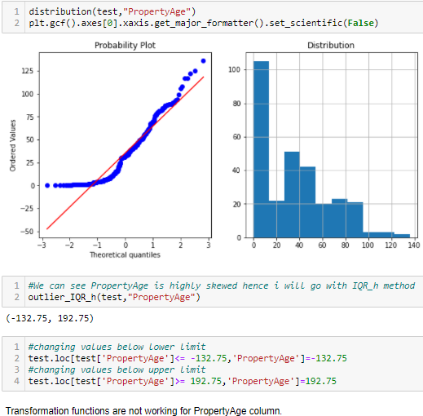

* **PPorch**

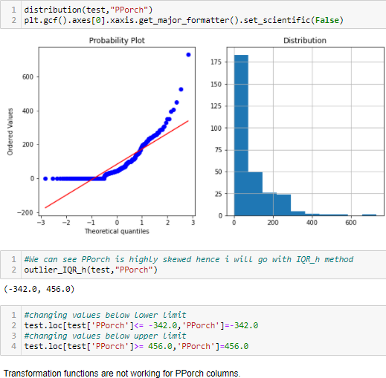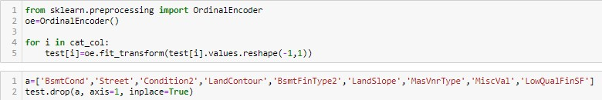

**Skewness and outliers removal:**

We have already delt with outliers.

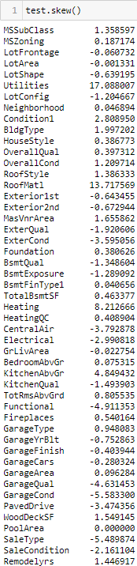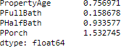

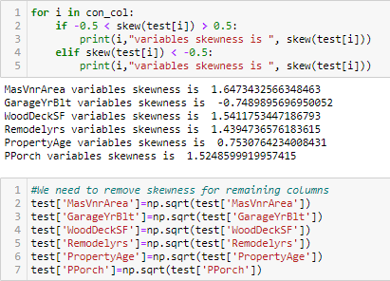

### Lets perform standardization:

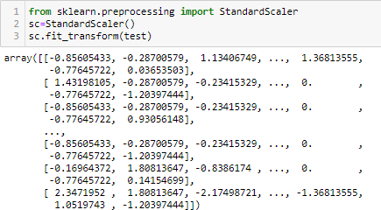

**Model/s Development and Evaluation**

**Finding best random state:**

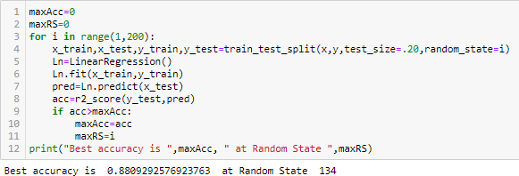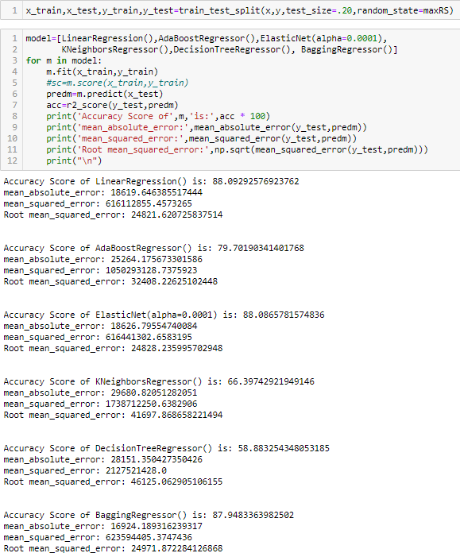

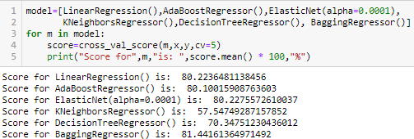**Cross Validation of model:**

With AdaBoostRegressor model there is very less difference in accuracy and cross validation score, Hence the best model is AdaBoostRegressor as per cross validation. Let's perform some hyper parameter tunning on models.

**Hyper parameter tunning:**



* LinearRegression

•

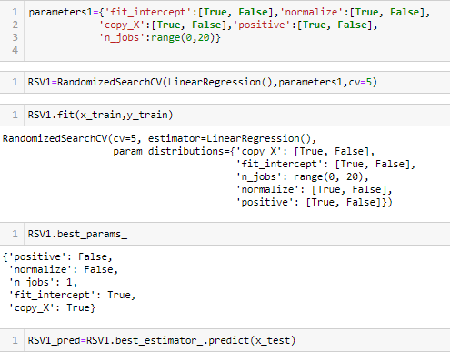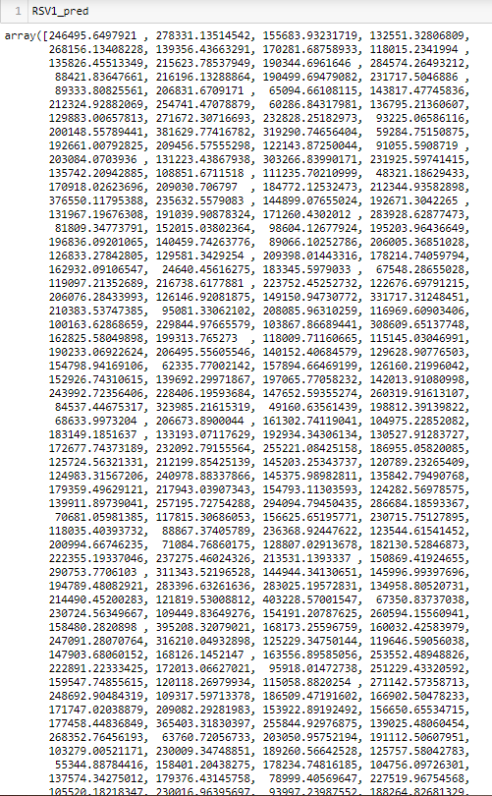

* 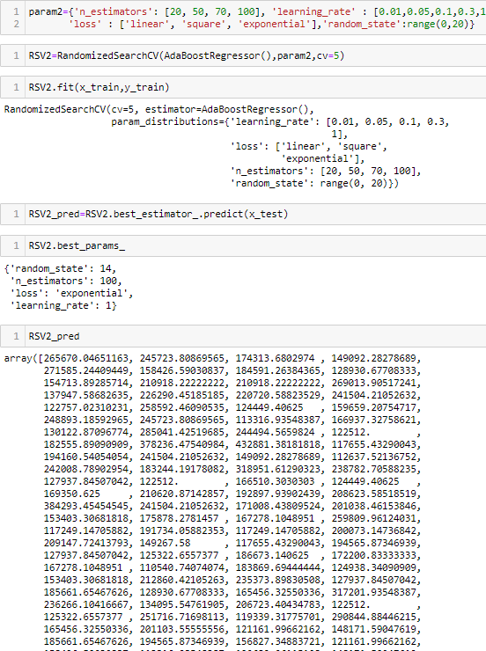AdaBoostRegressor



* 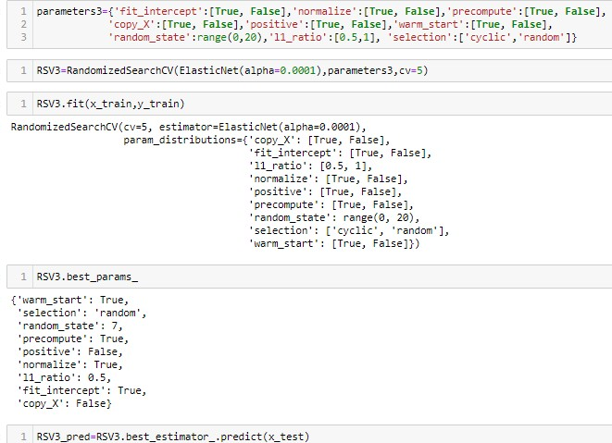ElasticNet

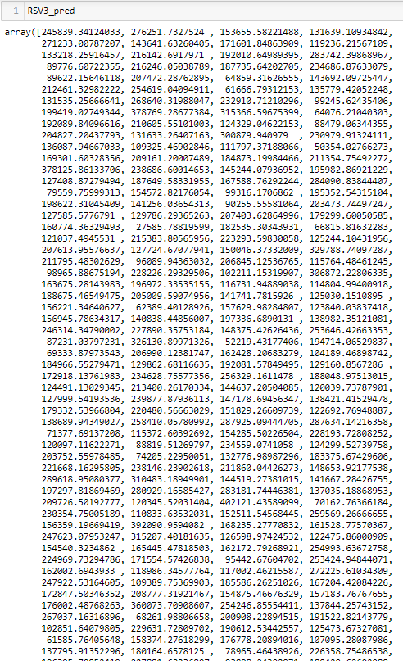

* 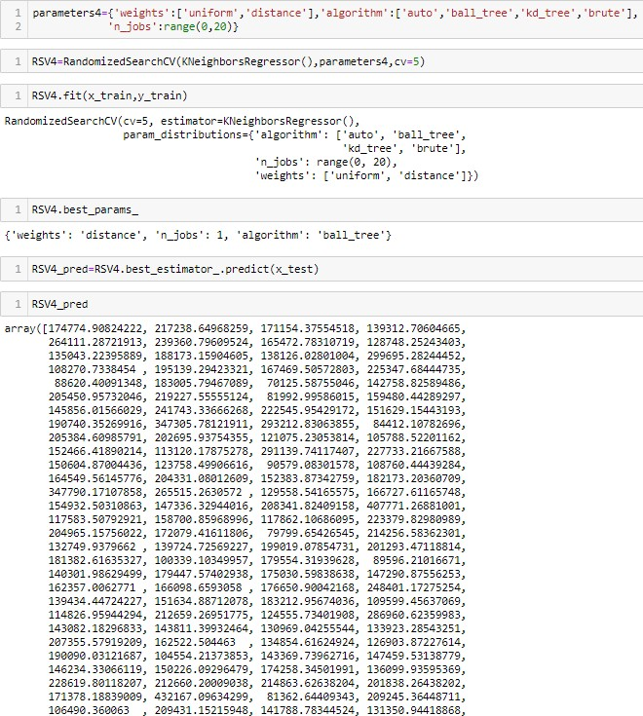KNeighborsRegressor



* DecisionTreeRegressor

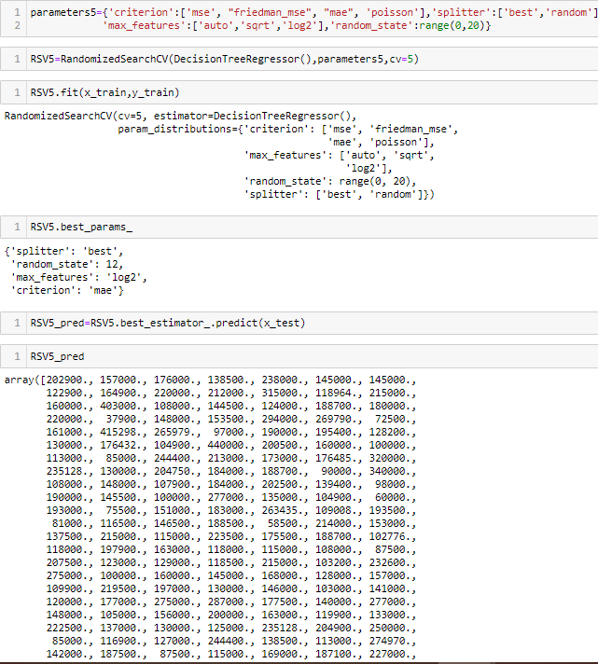

* BaggingRegressor

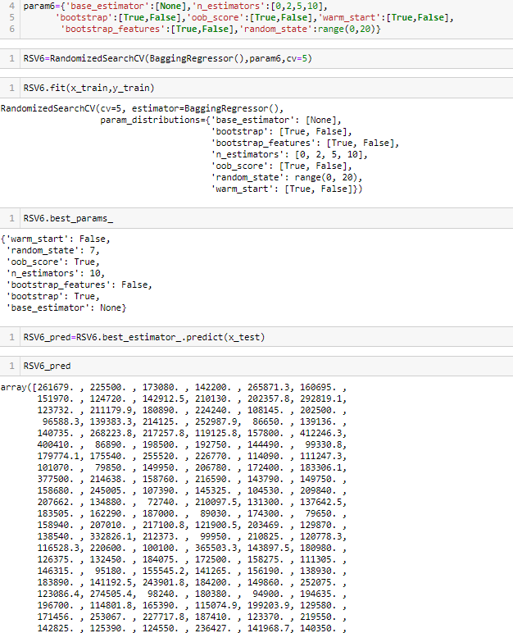



After performing RandomizedSearchCV method accuarcy:

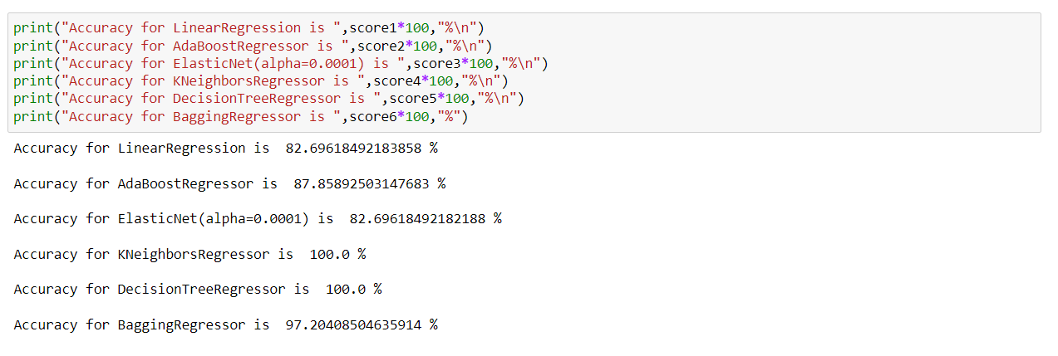

Selecting DecisionTreeRegressor as final model for saving, As can see some models are

over fitted.

**Saving The best Model:**

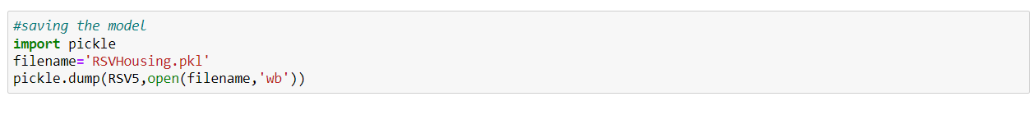

## load the model

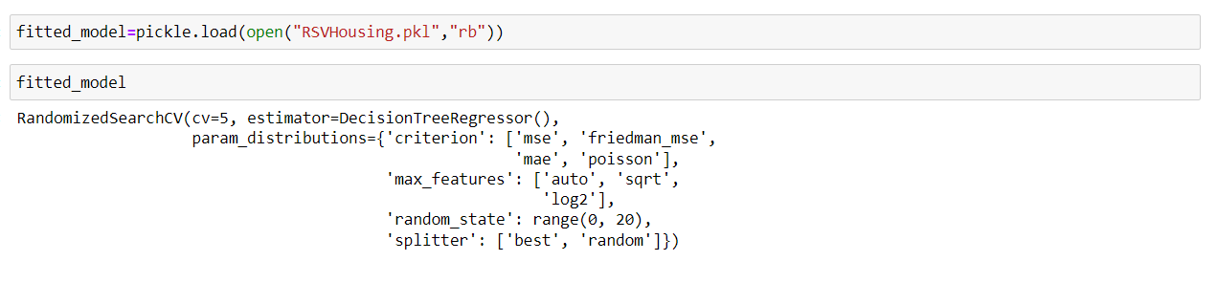

### prediction over test data

### 

**CONCLUSION**

Building a data science model for the management to understand the pricing dynamics of a new market. Our train dataset contains 1460 entries each having 81 variables and also contains Null values. And the test dataset contains 292 entries each having 80 variables and also contains Null values. I have worked on null values. Then created some new variables and deleted some which were not required after creating new variables. Then worked on outlier and skewness of the data for both the dataset. As our dataset contains object and numerical data hence with the help of ordinal encoding method, I have changed the data type to numeric and then standardization method help me in making the data in standard format.

Then tried finding the best random state to work on, after that we stated 6 models on our train dataset and with the help of GridsearvhCV method i tried to improve the accuracy, I choose DecisionTreeRegressor for final saving the model the then loaded the model on test dataset and then predicted the data over test dataset.